**Full System Regression (.Net Core 2 & Bootstrap 4 Migrations.)  
Tested on I.E.  
  
Notes: Anywhere that “panel” is mentioned please replace with “section.”  
  
Common Forms**Certify My User Accounthttp://spireportal-test.spire.com/ForceCertification *Fail (Bootstrap)*Nothing in Fields: *Fail* *(Error Message & Highlights)*  
Information in Fields: Pass (Success Message)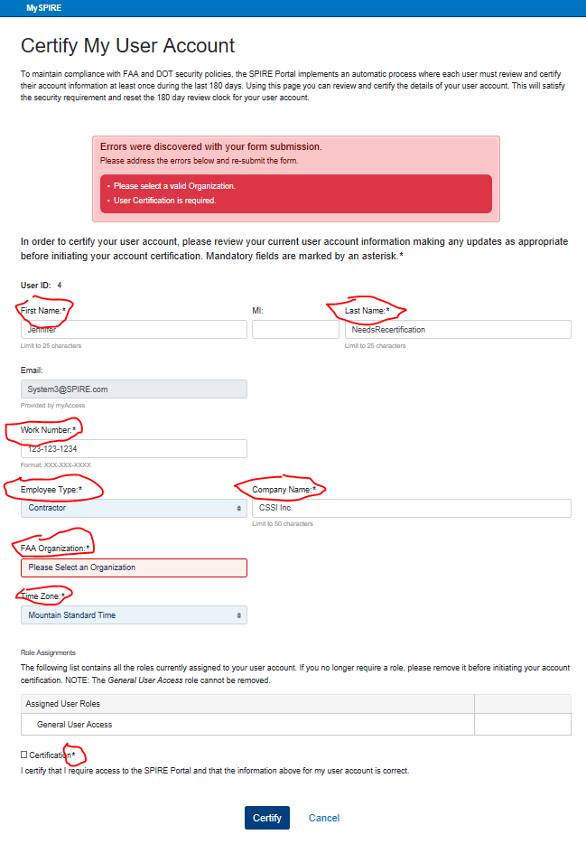

**Common Services**Help Center<http://spireportal-test.spire.com/Help> *Fail (Code – Hard Crash)  
Fail (Bootstrap & Responsiveness)*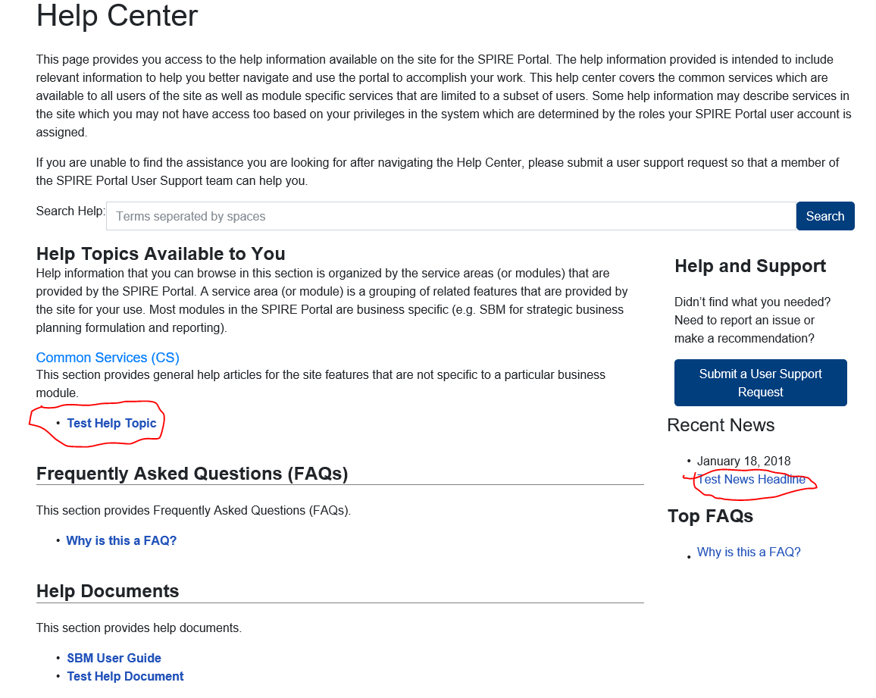 🡪 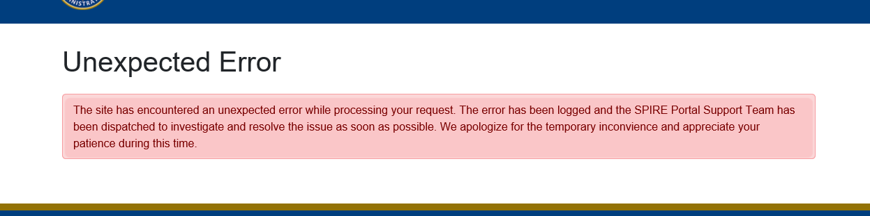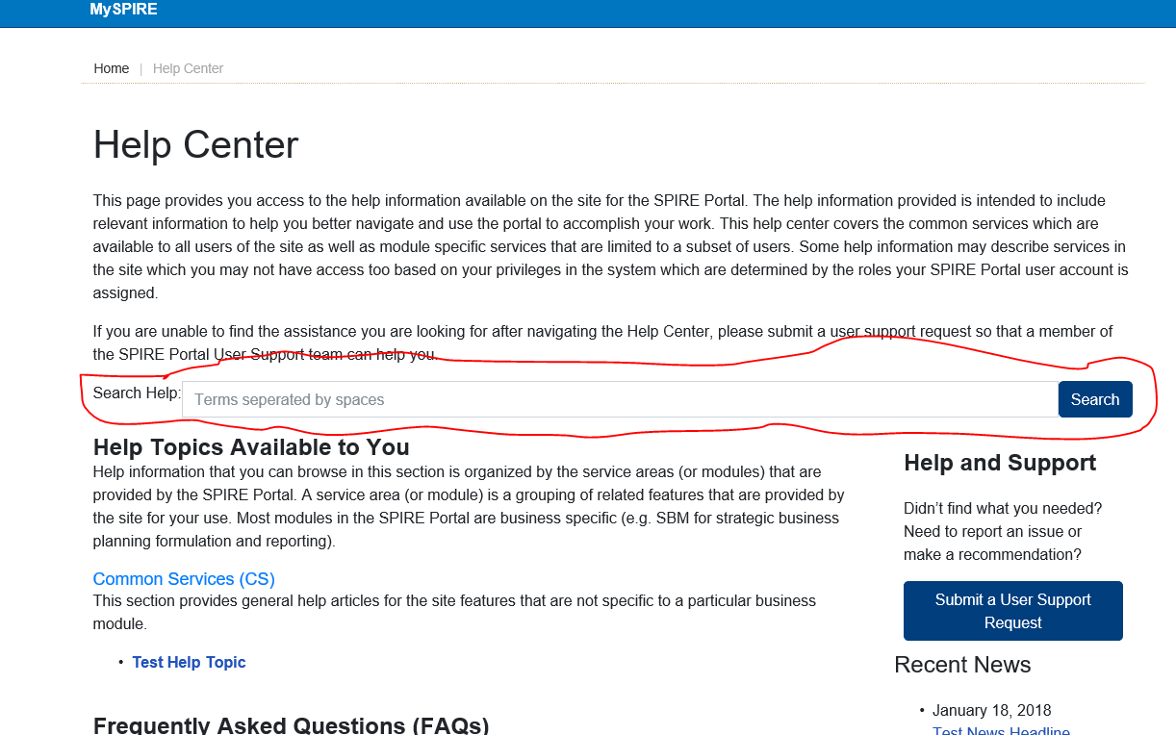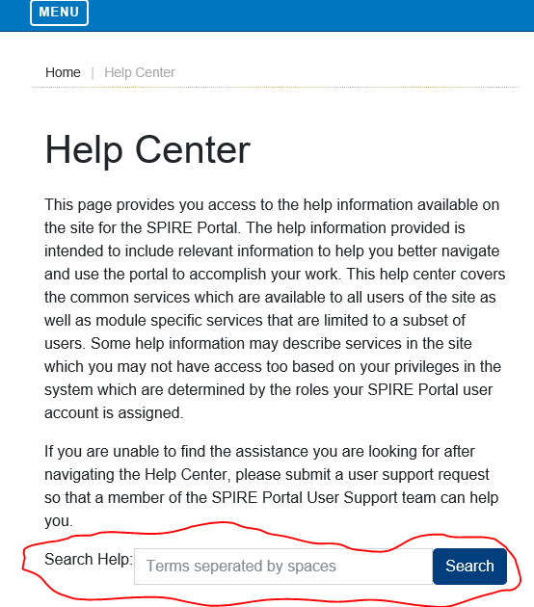Submit User Support Request:   
<http://spireportal-test.spire.com/UserSupportRequest/Create>Nothing in Fields: Pass (Error Message & Highlights)  
Information in Fields: Pass (Success Message)Frequently Asked Questions (FAQs):<http://spireportal-test.spire.com/FAQ?faq=1#question_1>Pass (Code)  
Fail (Bootstrap & Responsiveness)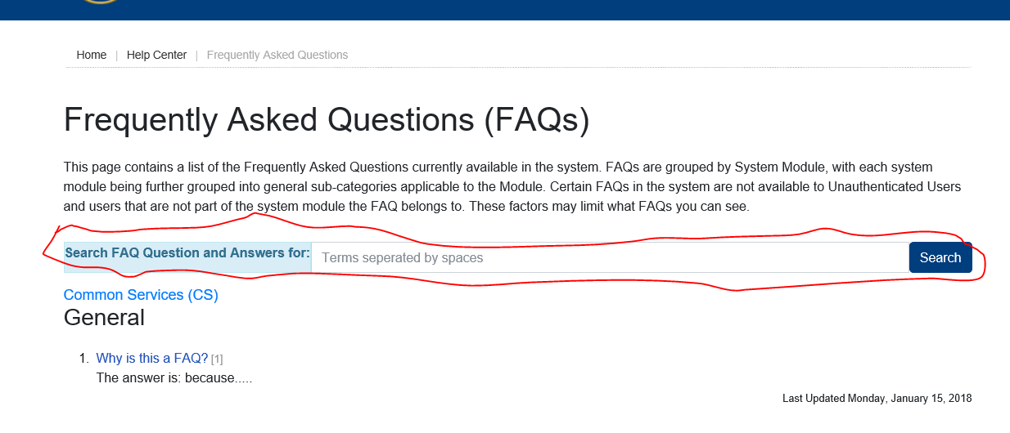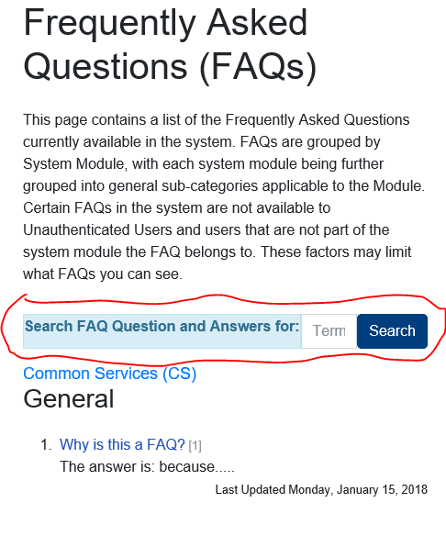SPIRE Home  
http://spireportal-test.spire.com/  
*Pass***More News (link)**Fail (Hard Crash)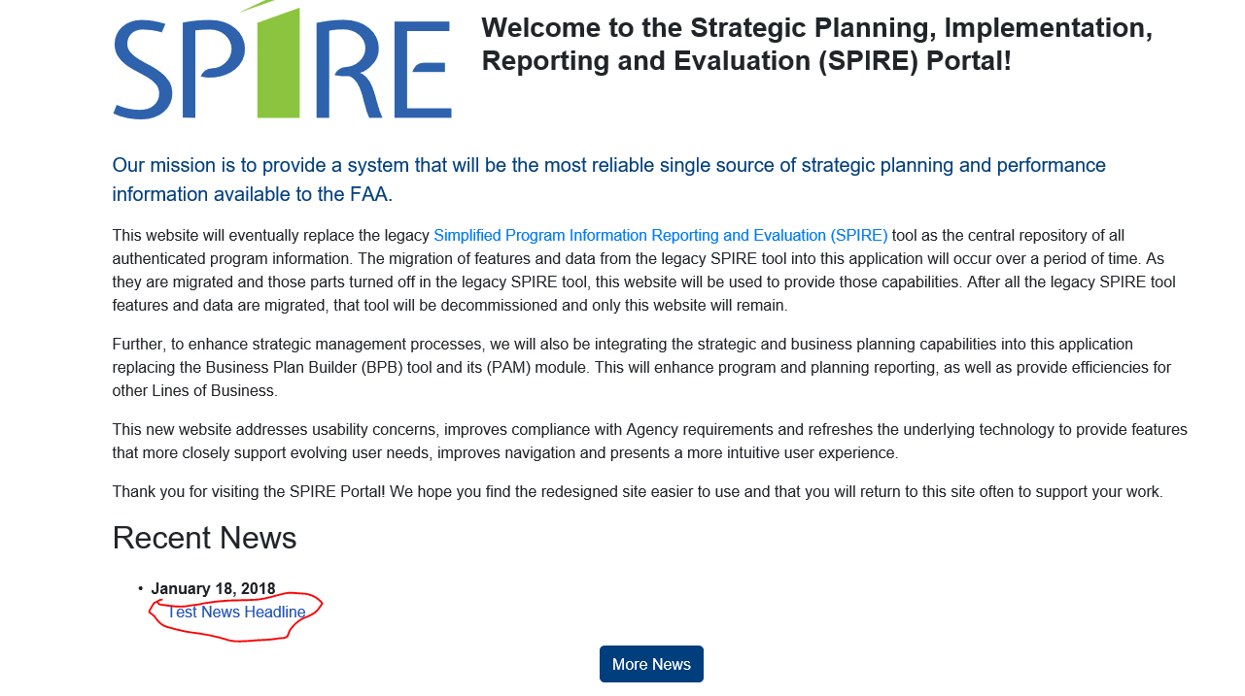 🡪 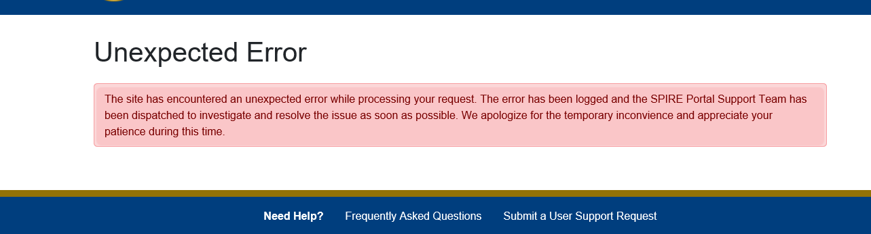LOGINhttp://spireportal-test.spire.com/Login*Fail (Bootstrap) – Login Image is too large  
Pass (Code)*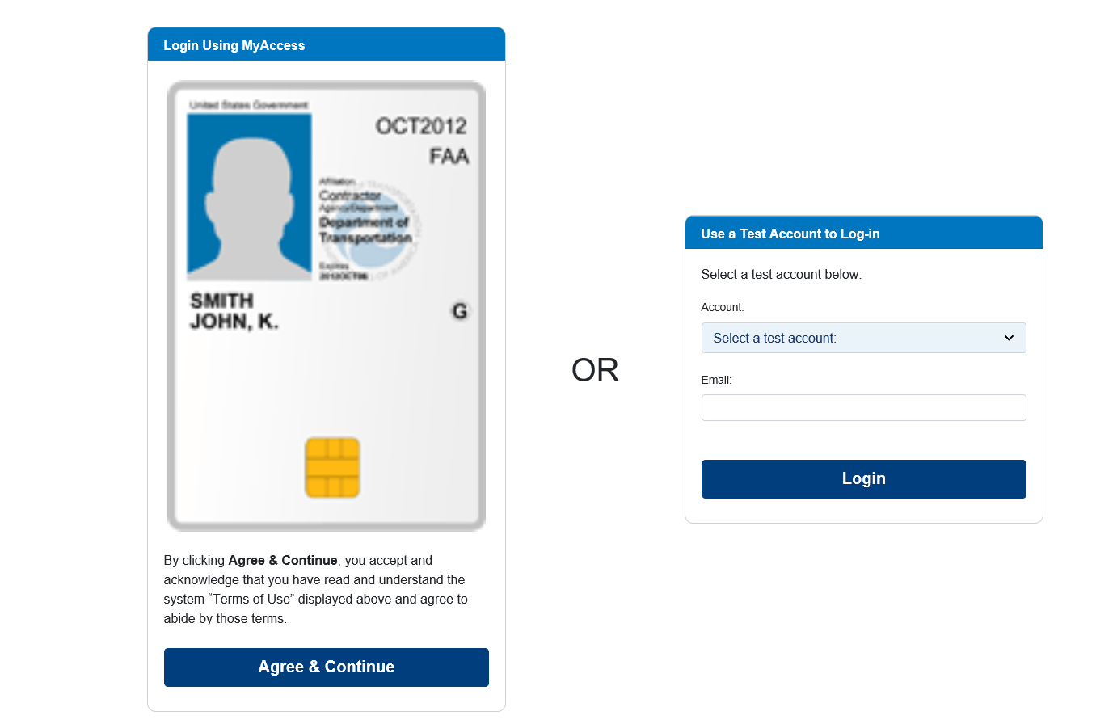  
MySPIRE  
http://spireportal-test.spire.com/MySpire*Pass**Pass (Bootstrap)*My Account  
http://spireportal-test.spire.com/Myaccount*Pass (Code)  
Fail (Bootstrap & Responsiveness)*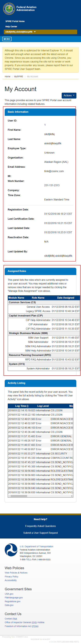

**Actions Dropdown**Review And Certify  
<http://spireportal-test.spire.com/UserCertification/Create>  
*Pass (Code)*Nothing in Fields***:*** *Pass (Error Message)*Information in Fields:*Pass (Success Message)*

Edit User Information<http://spireportal-test.spire.com/MyAccount/Edit>  
*Pass (Code)*Nothing in Fields: Pass (Error Message)  
Information in Fields: Pass (Success Message)

Manage Role Assignment  
<http://spireportal-test.spire.com/MyAccount/MyRoleManagement>  
*Pass (Code)  
Fail* (Bootstrap)  
  
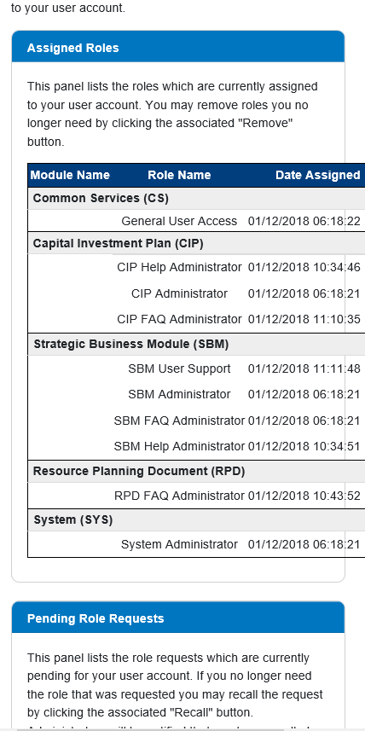

**Assigned Roles**

**Actions:**

Remove*Pass* (Code)  
*Pass (Success Message)  
Fail* (Bootstrap)  
  
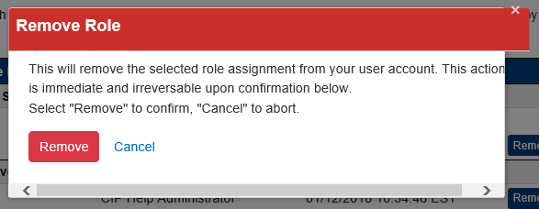 ***Pending Role Requests  
  
Actions***Recall*Pass* *(Code)*  
*Pass (Success Message)  
Fail* (Bootstrap)  
  
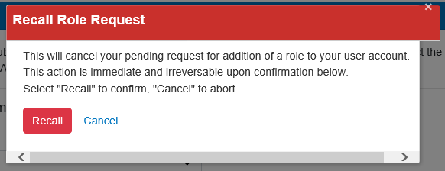 ***Request Additional Roles:****Pass* (Code)  
*Information in Fields: Pass (Success Message)**Nothing in Fields: Fail – Code & Bootstrap (Errors Not Highlighted)*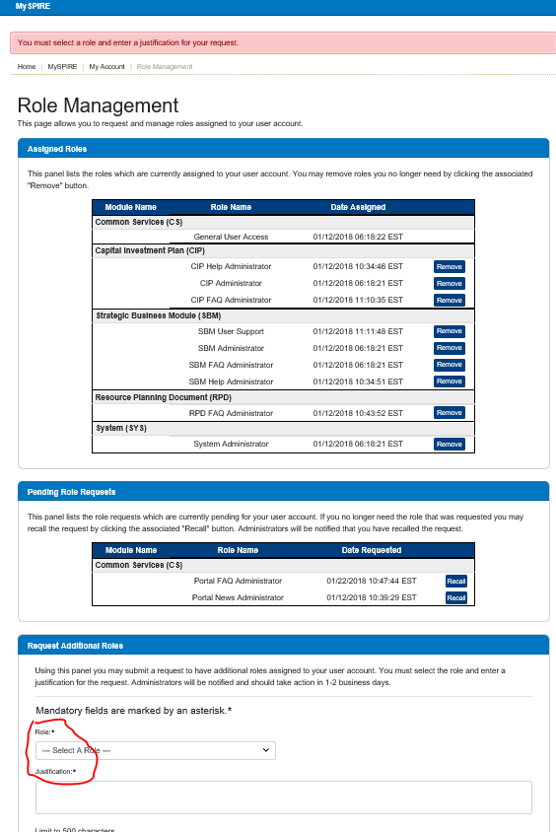**My Activity Log**<http://spireportal-test.spire.com/MyActivityLog>*Pass (Code)  
Fail* (Bootstrap & Responsiveness)  
  
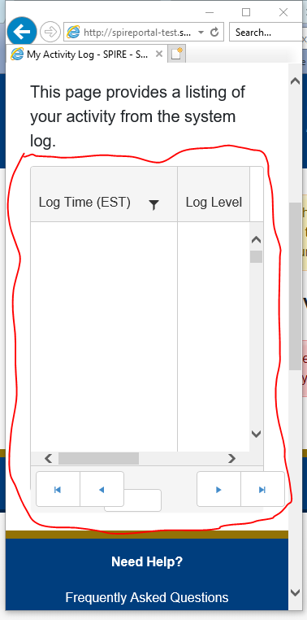 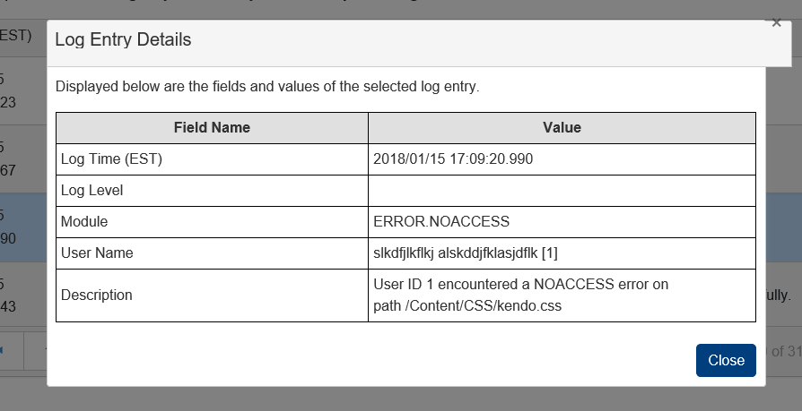

My Notifications<http://spireportal-test.spire.com/MyNotifications>*Pass  
Fail (Bootstrap & Responsiveness)*

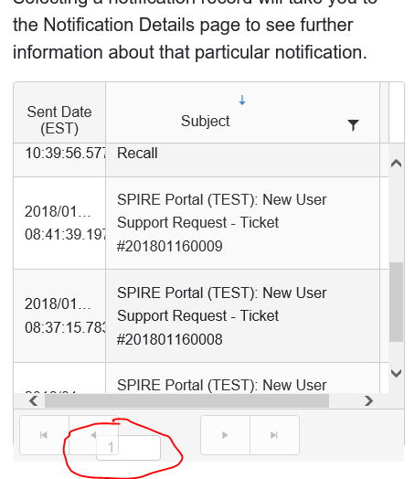

Notifications Detail  
[http://spireportal-test.spire.com/MyNotifications/Display/13*Pass (Code)  
Fail (Bootstrap & Responsiveness)* 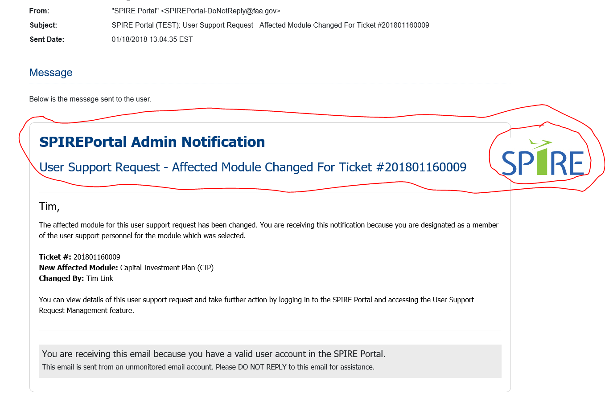](http://spireportal-test.spire.com/MyNotifications/Display/13Pass%20(Code)Fail%20(Bootstrap))My Support Requests<http://spireportal-test.spire.com/MySupportRequest>*Pass(code)  
Fail (Bootstrap & Responsiveness)*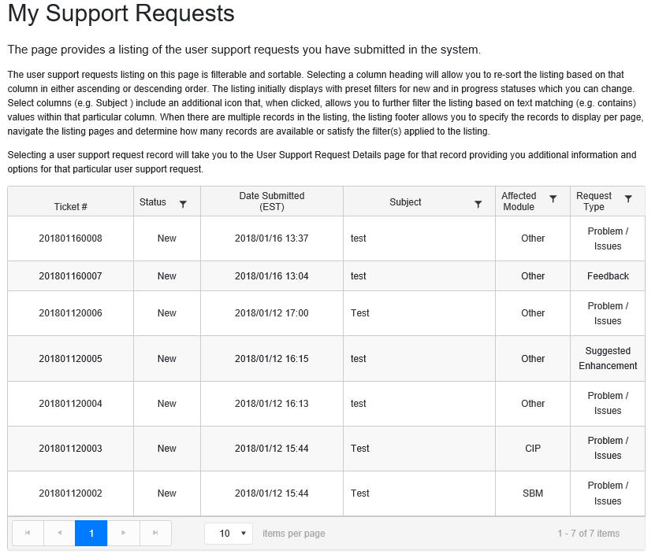 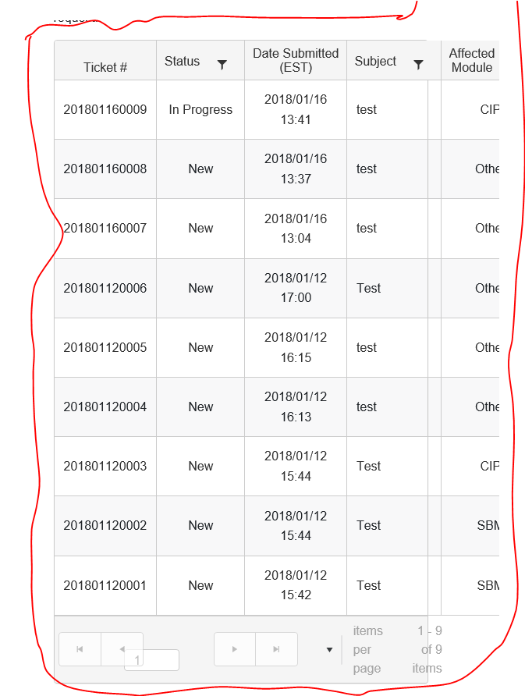Support Requests Details<http://spireportal-test.spire.com/MySupportRequest/Display/>*Pass(code)  
Pass (Bootstrap & Responsiveness)*Recent News ***Fail*** *(Code Hard Crash)*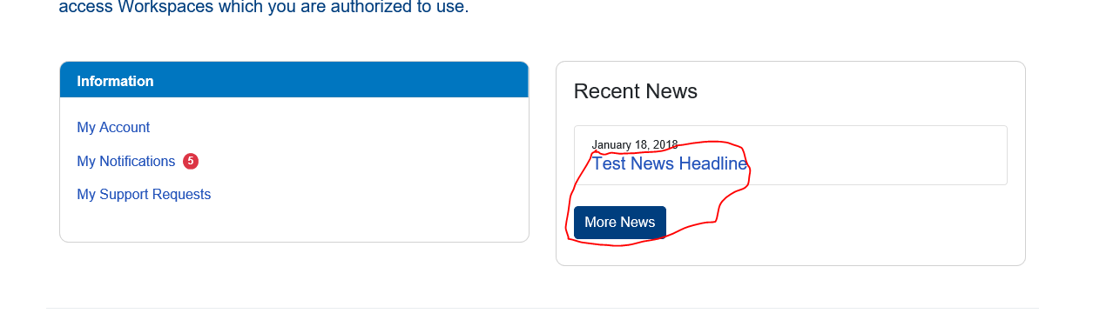 🡪 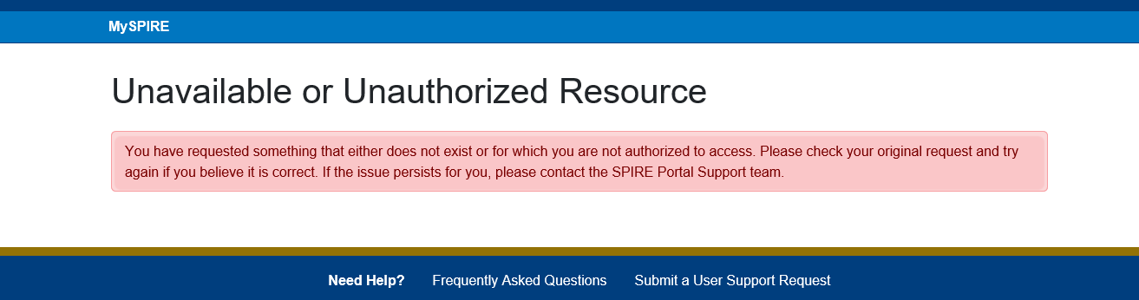  
  
**Workspaces  
  
Portal Administration & System Administration**http://spireportal-test.spire.com/PortalAdminhttp://spireportal-test.spire.com/SysAdminPass (Code)  
Pass *(Bootstrap & Responsiveness)* **General Management (Card)**--------------------------------------------------------------------------------------------------------------------------------------Automation System Account Management   
<http://spireportal-test.spire.com/AutomationSystemAccountManagement>  
*Pass(code)  
Fail (Bootstrap & Responsiveness)*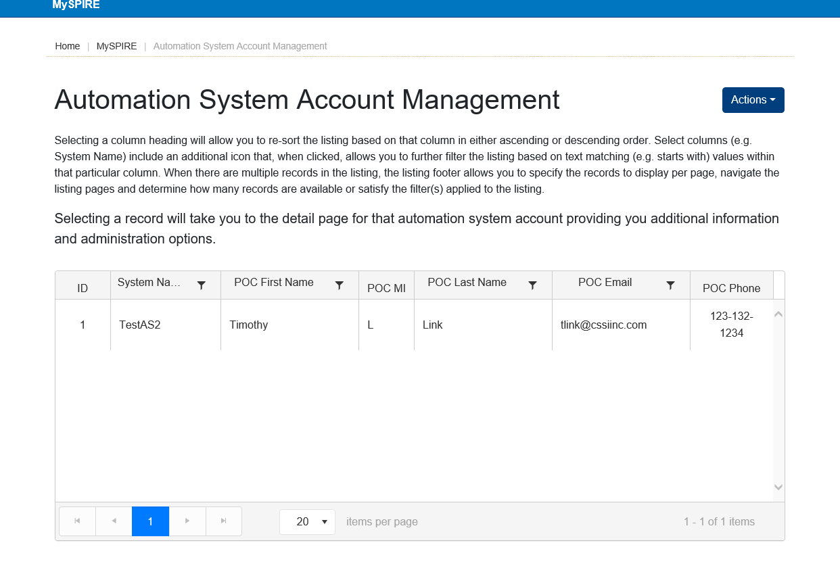 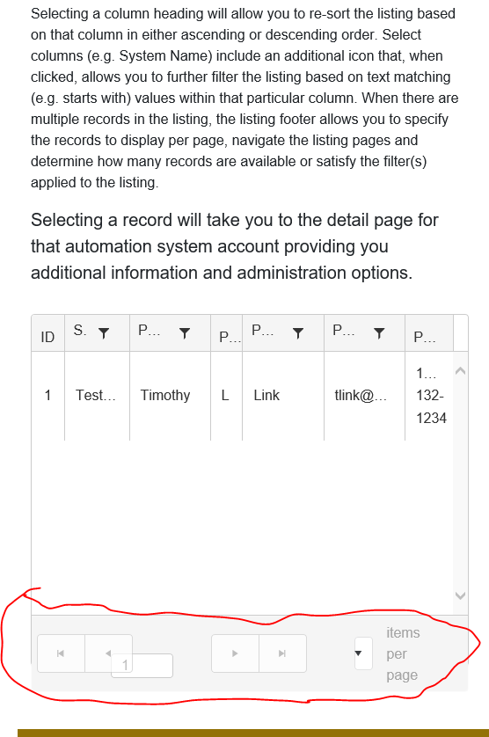  
  
***Actions Dropdown:***Create Automation Systems Account  
<http://spireportal-test.spire.com/AutomationSystemAccountManagement/Create>  
*Information in Fields: Pass (Success Message)**Nothing in Fields: Fail - Code (Asterisks Not Red)*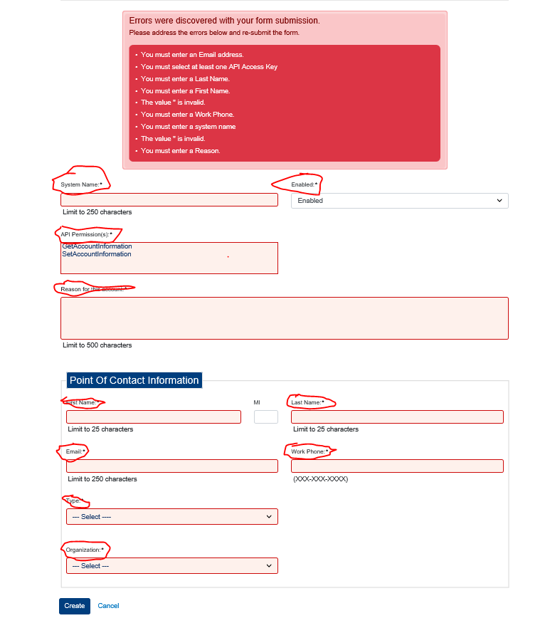Automation System Account Detail  
http://spireportal-test.spire.com/AutomationSystemAccountManagement/Display/2*Pass (Code)  
Fail (Bootstrap)*

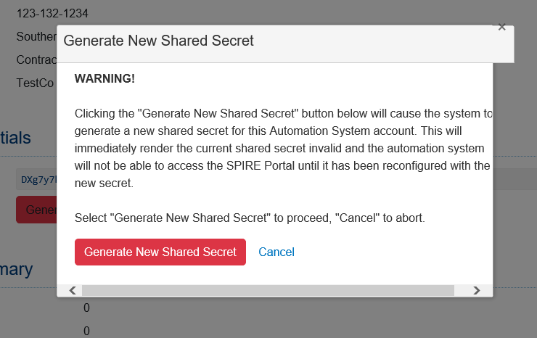***Actions Dropdown:***

Edit Automation System Account  
<http://spireportal-test.spire.com/AutomationSystemAccountManagement/Edit/1>  
*Nothing in Fields: Pass (Error Message-Top)   
Information in Fields: Pass (Success Message)  
Fail (Bootstrap Asterisks Not Red)*

*-------------------------------------------------------------------------*  
Broadcast Notification Management  
http://spireportal-test.spire.com/BroadcastNotifications/Index/5  
*Pass (Code)  
Fail (Bootstrap)*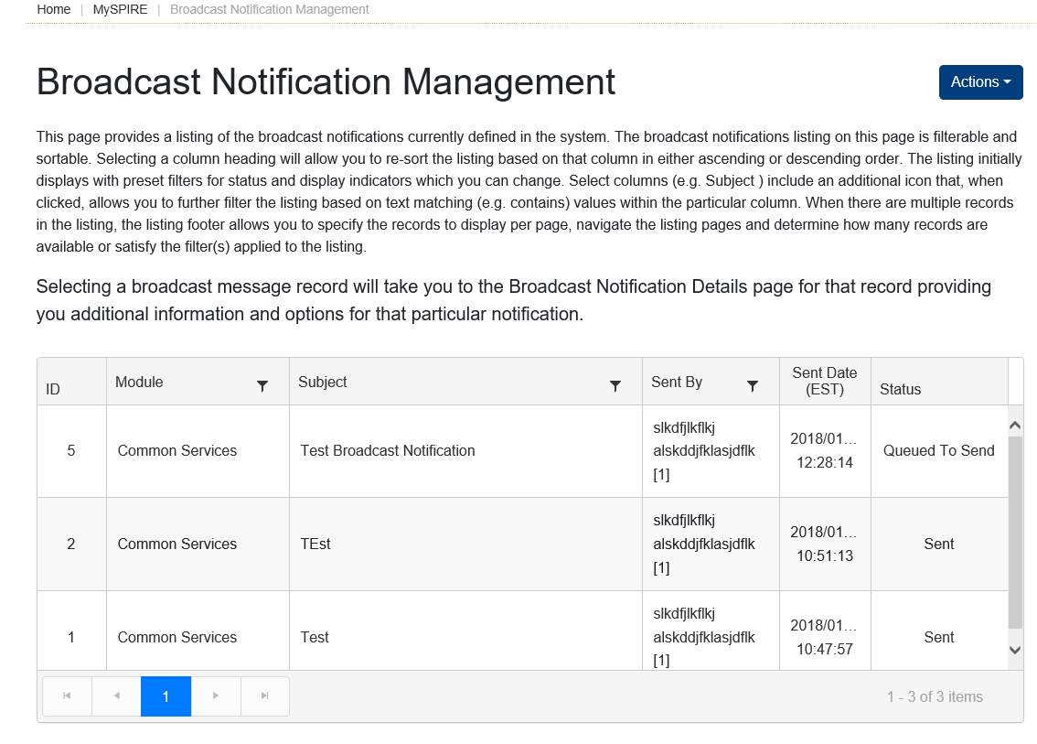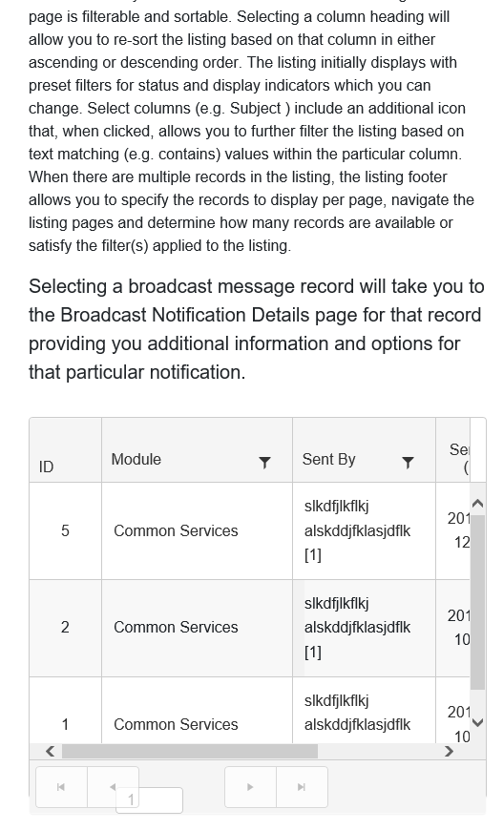

***Actions Dropdown:***

Create New Broadcast Notification  
<http://spireportal-test.spire.com/BroadcastNotifications/Create>  
*Pass (Code)  
Information in Fields: Pass (Success Message)**Fail (Bootstrap)**Nothing in Fields: Fail (Error Message-Top only displays 3 errors and there should be 5 )*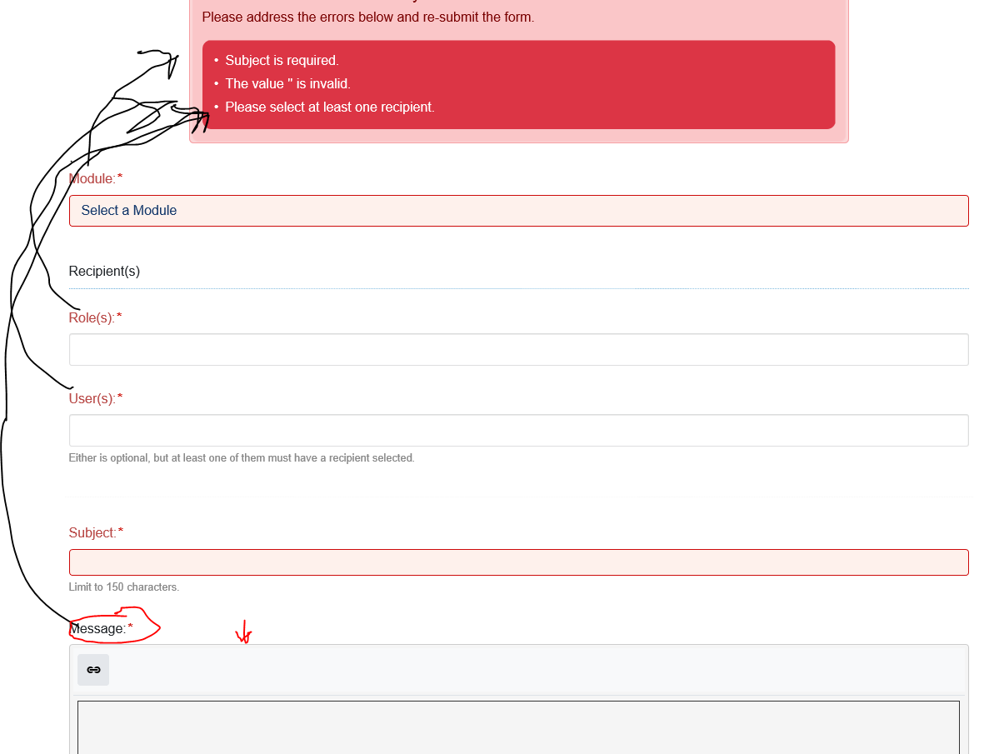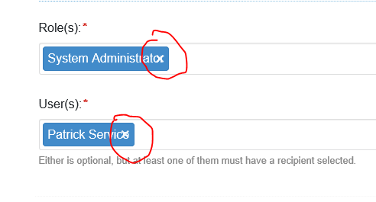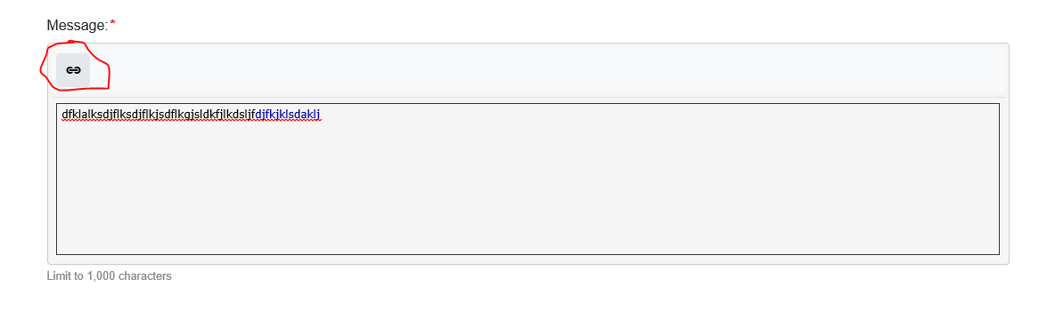🡪 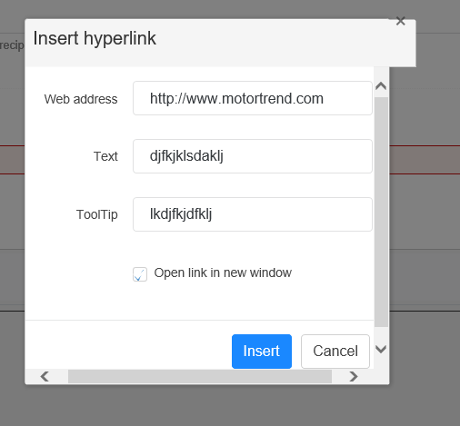

Preview Broadcast Notification  
<http://spireportal-test.spire.com/BroadcastNotifications/Display/6>  
*Pass (Bootstrap & Responsiveness)**Fail (Code Crash)*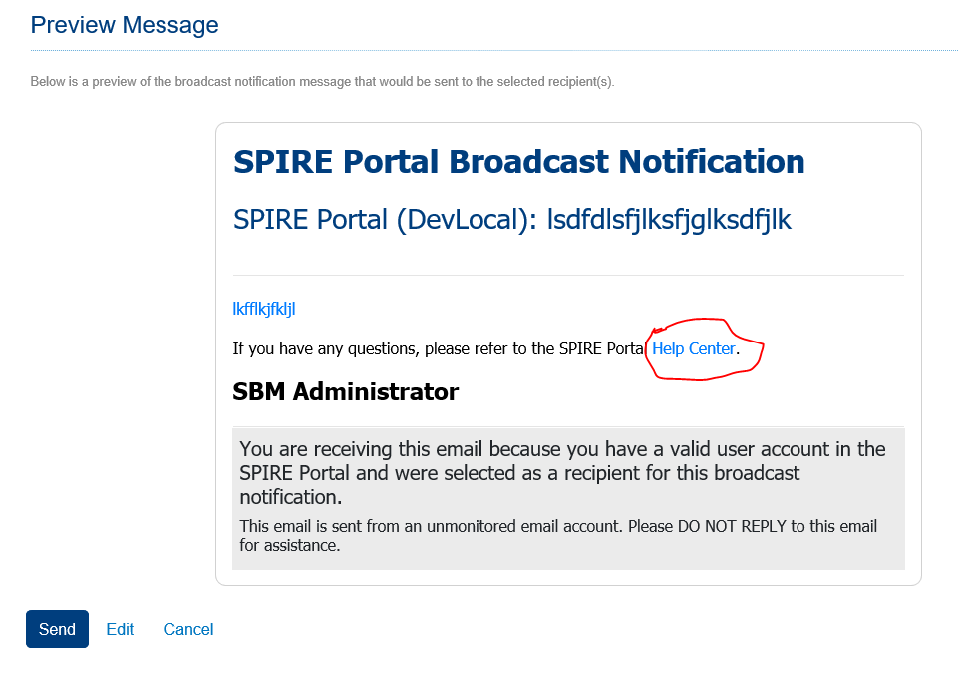 **🡪**  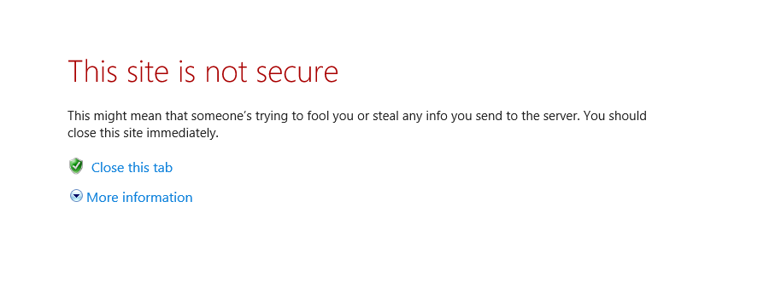Edit Broadcast Notification  
<http://spireportal-test.spire.com/BroadcastNotifications/Edit/6>  
*Information in Fields (Send): Pass (Success Message)*  
*Fail (Bootstrap) – Title of page should read “Edit Broadcast Notification” as the URL indicates.**Nothing in Fields: Fail (Error Message-Top only displays 3 errors and there should be 5 )*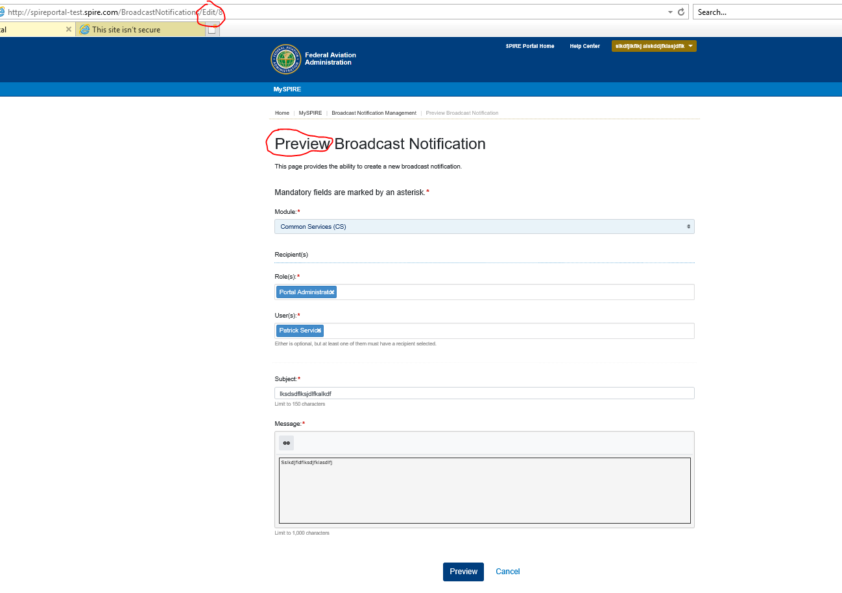  
-------------------------------------------------------------------------  
Role Request Management  
<http://spireportal-test.spire.com/RoleRequestAdmin>*Pass (Code)*  
*Fail (Bootstrap)*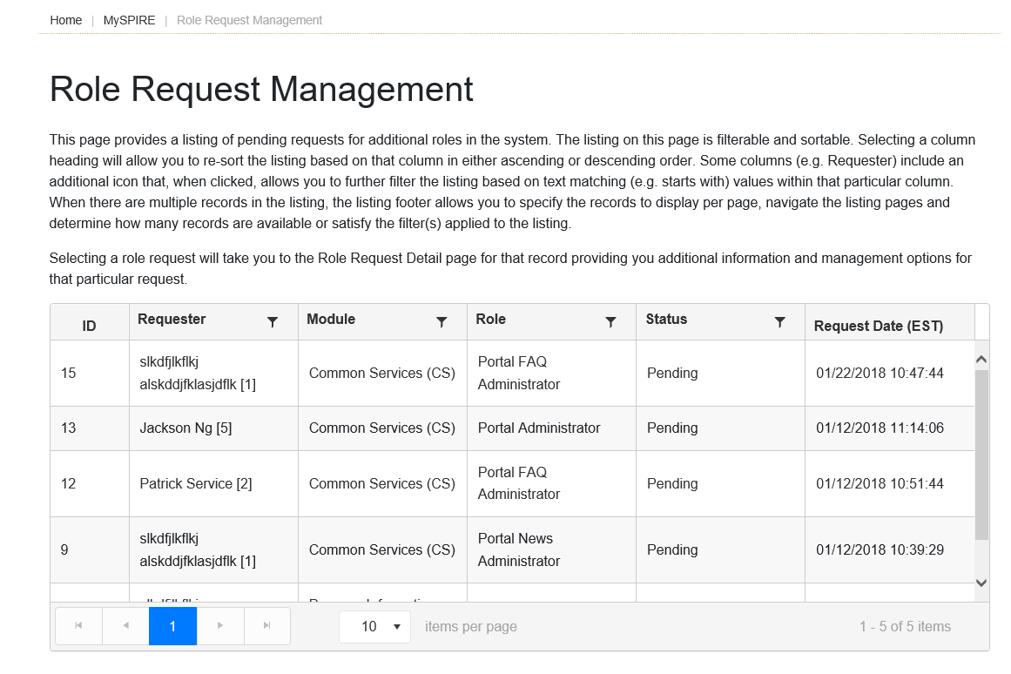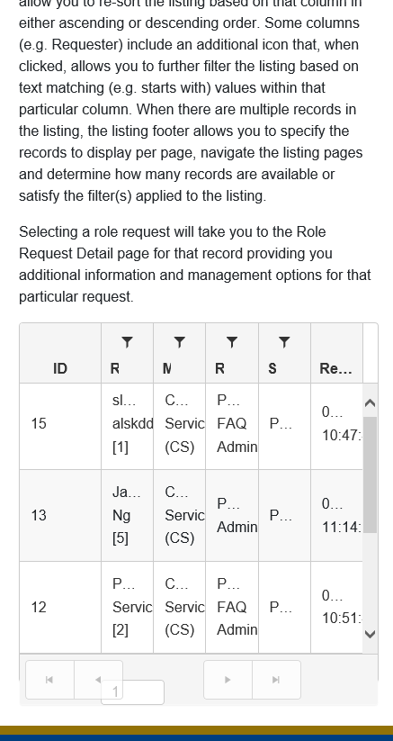🡪 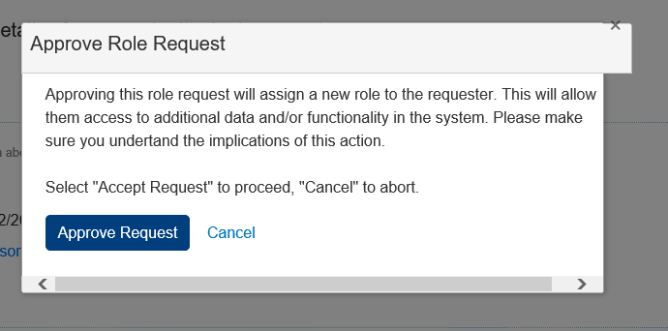 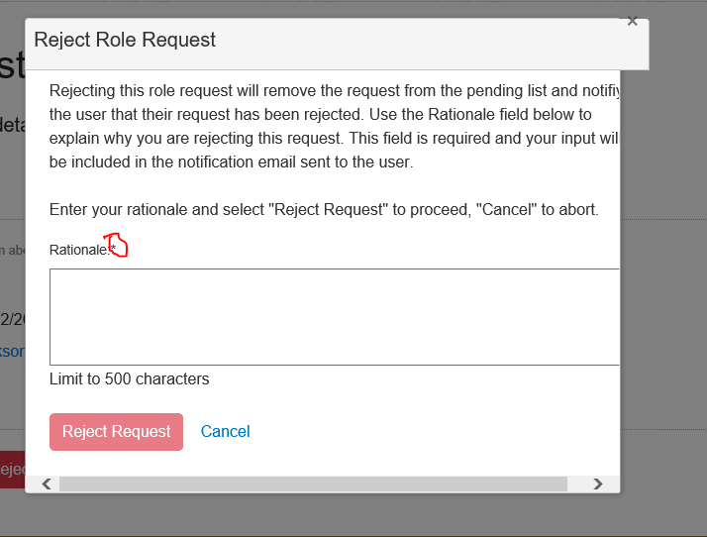  
  
-------------------------------------------------------------------------  
System Message Management  
<http://spireportal-test.spire.com/SystemMessageManagement>*Pass (Code)**Fail (Bootstrap)*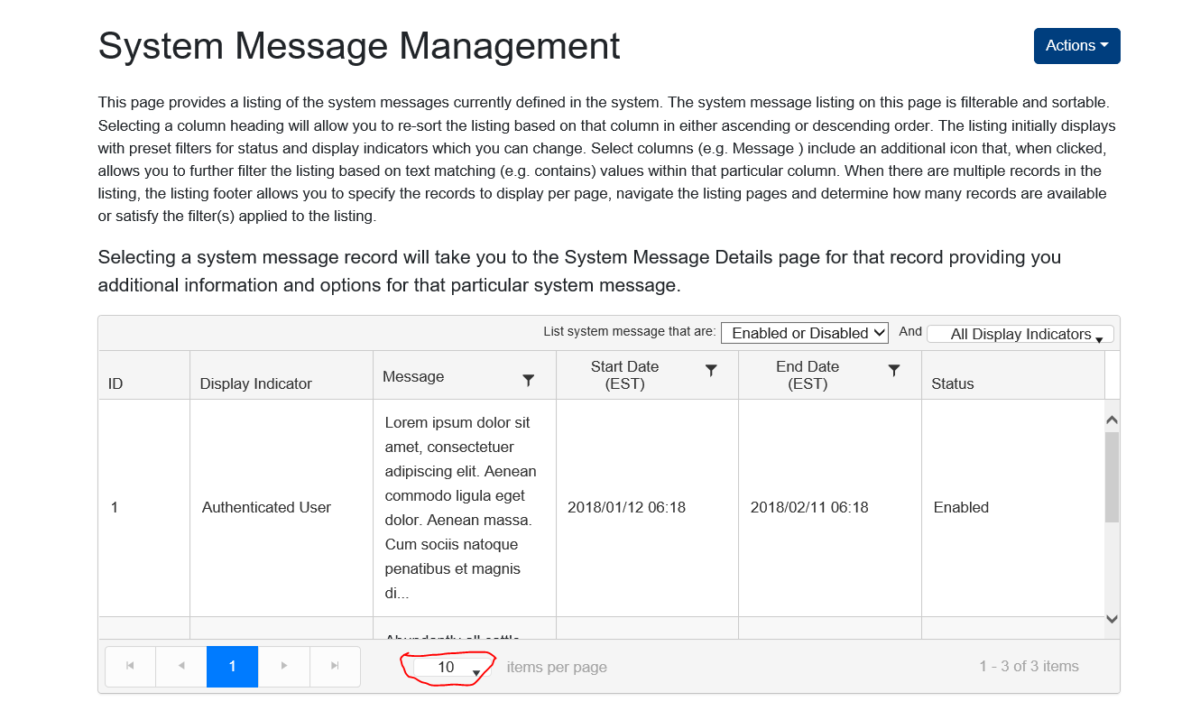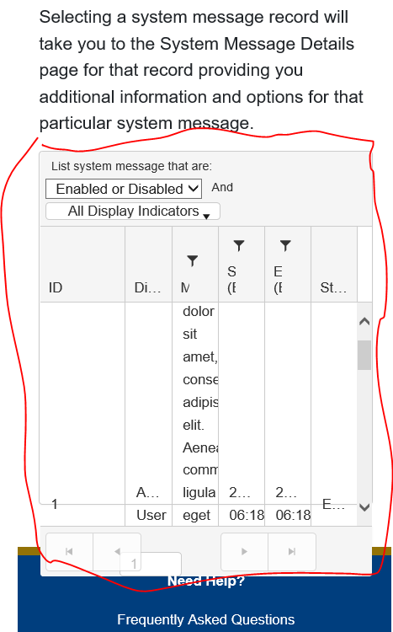 ***Actions Dropdown:***

Create New System Message  
<http://spireportal-test.spire.com/SystemMessageManagement/Create>  
*Fail (Bootstrap)**Nothing in Fields: Fail (Error Message-Top only displays 2 errors and there should be 6 )  
Information in Fields: Pass (Success Message)*  
  
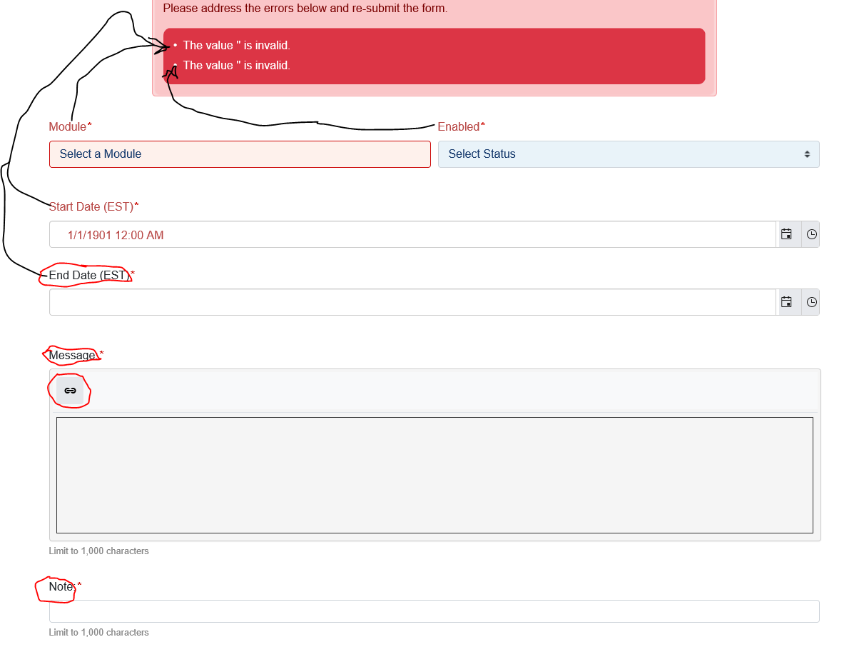 🡪   
  
System Message Details  
<http://spireportal-test.spire.com/SystemMessageManagement/Display/3>  
*Pass (Code)**Pass (Bootstrap)*  
-------------------------------------------------------------------------  
User Administration  
<http://spireportal-test.spire.com/UserManagement>  
*Pass (Code)*  
*Fail (Bootstrap)*  
  
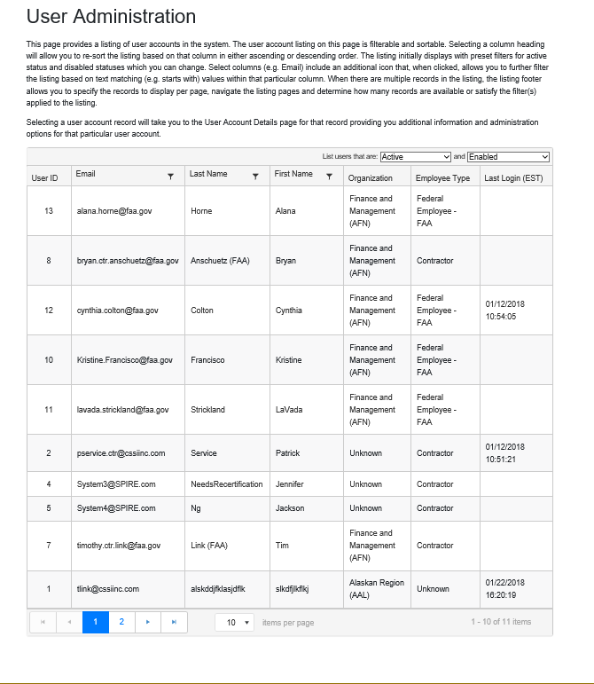 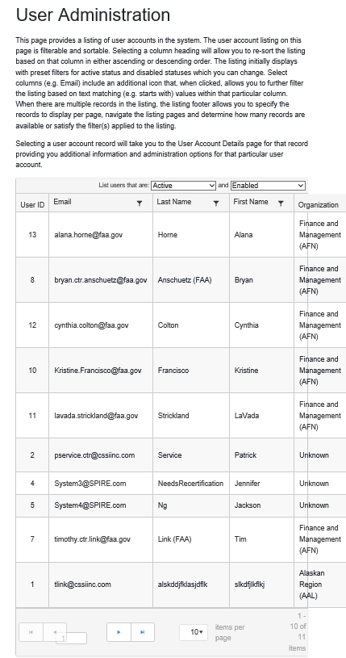  
  
User Account Details  
<http://spireportal-test.spire.com/UserManagement/Display/13>  
*Pass (Code)*  
*Fail (Bootstrap)*  
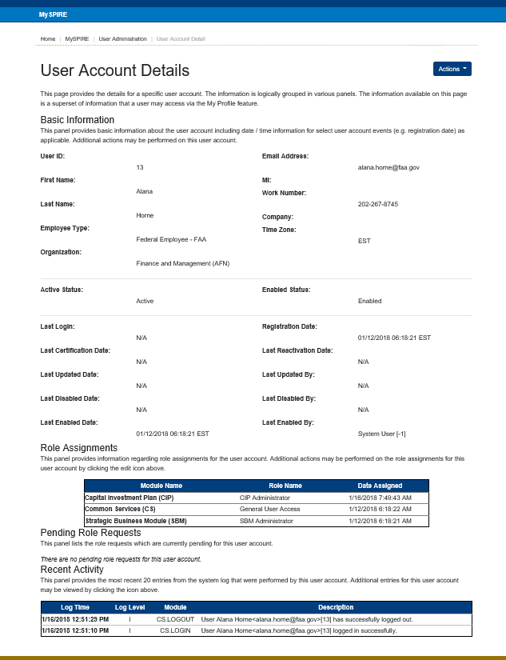 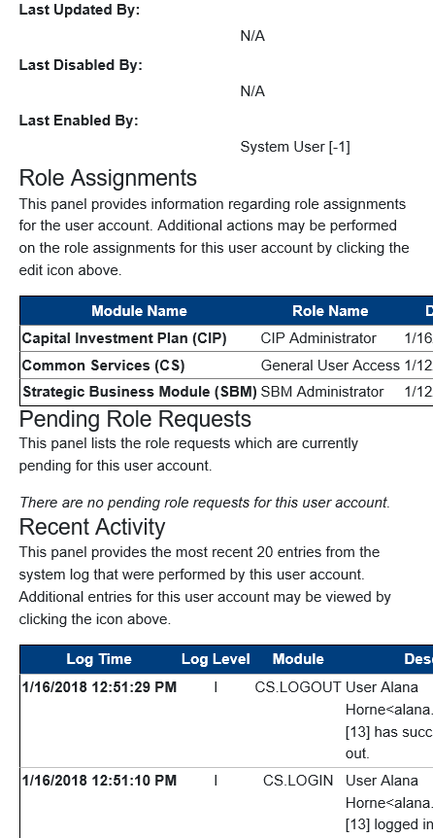***Actions Dropdown:***Edit Email Address<http://spireportal-test.spire.com/UserManagementEmail/Edit/13>  
*Nothing in Fields: Pass (Error Messages and highlights)  
Information in Fields: Pass (Success Message)*  
*Fail (Bootstrap) 2 Asterisks*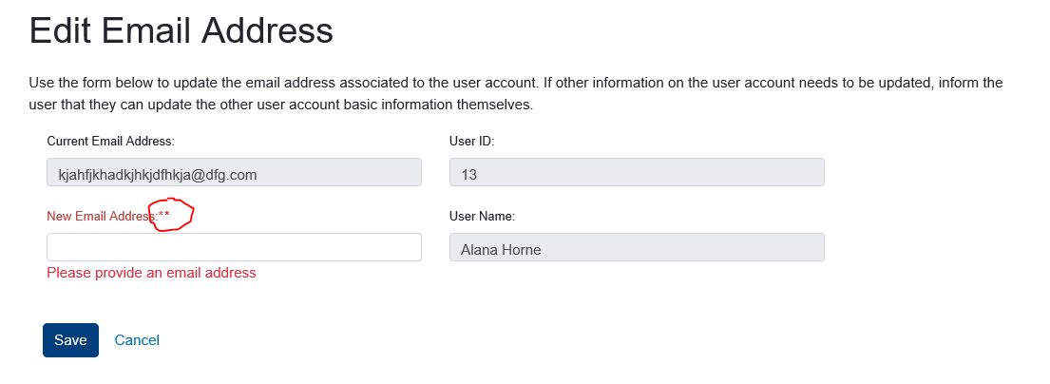

Manage Role Assignments<http://spireportal-test.spire.com/UserRoles/Edit/13>  
*Pass (Code) – Success Message for Removing Role Assignment  
Pass (Code) – Assigning Role*  
*Fail (Bootstrap)*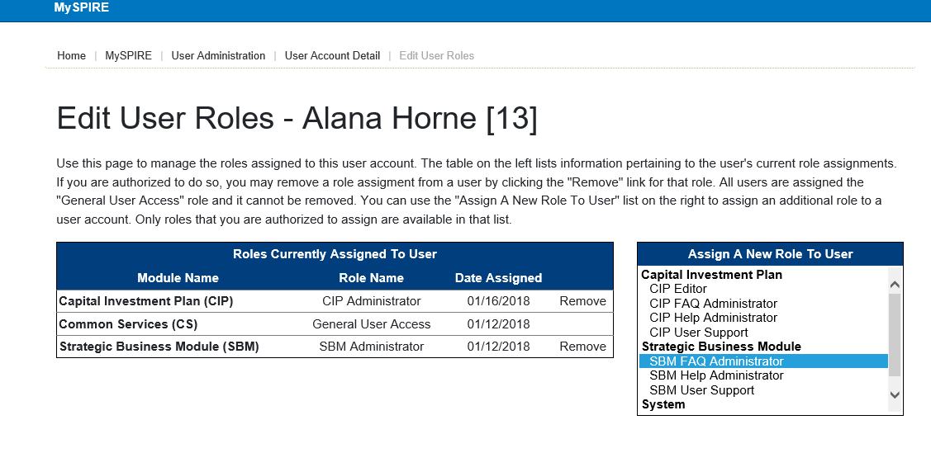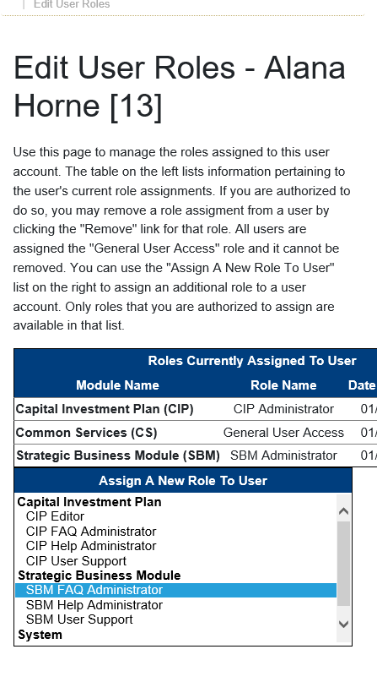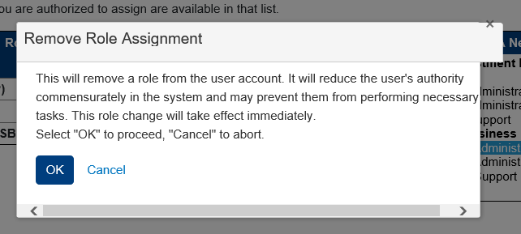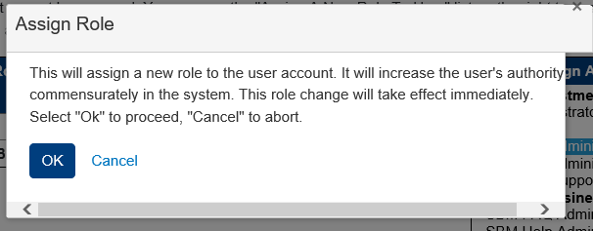User Account Activity<http://spireportal-test.spire.com/UserActivity/Index/13>  
*Pass (Code)*  
*Fail (Bootstrap)*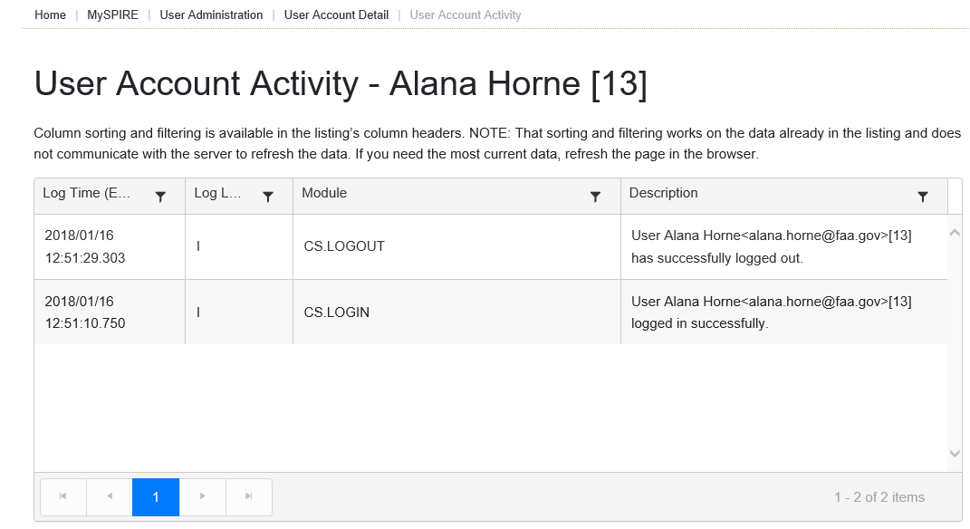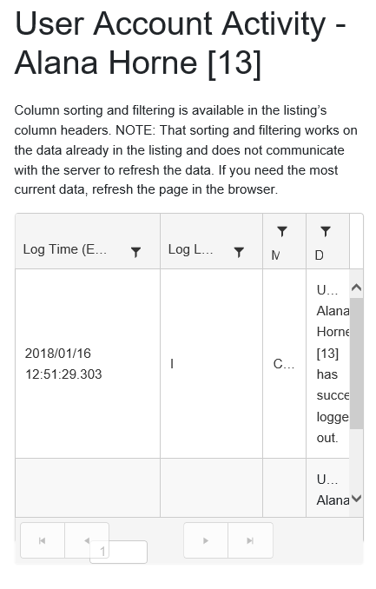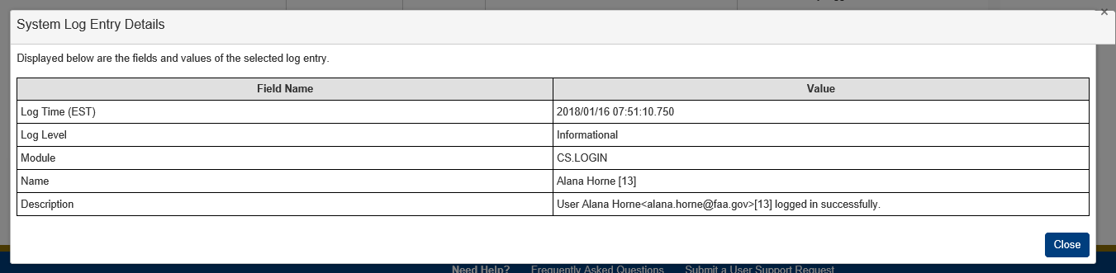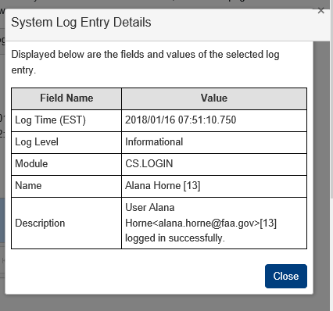  
-------------------------------------------------------------------------  
User Support Request Management  
<http://spireportal-test.spire.com/UserSupportRequestManagement>  
*Pass (Code)*  
*Fail (Bootstrap)*  
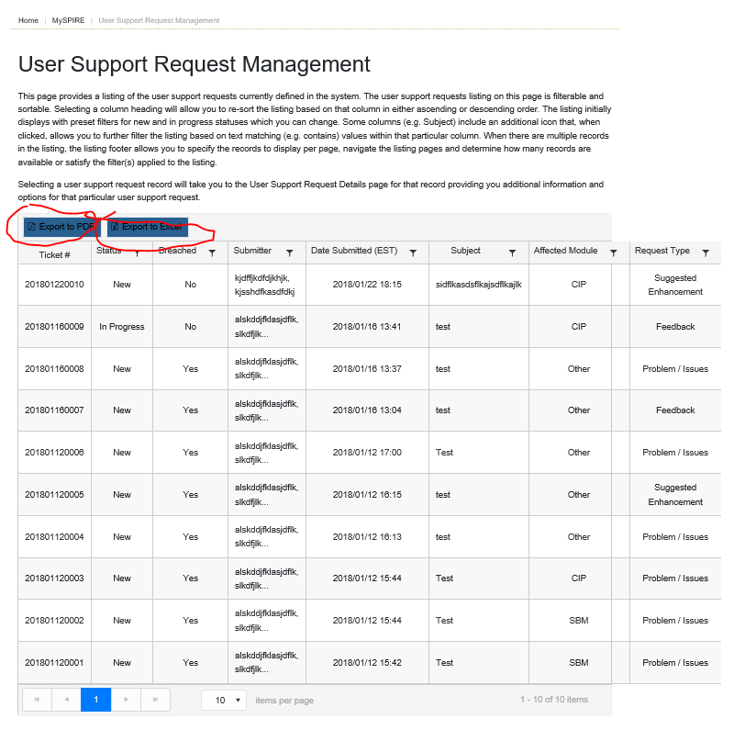 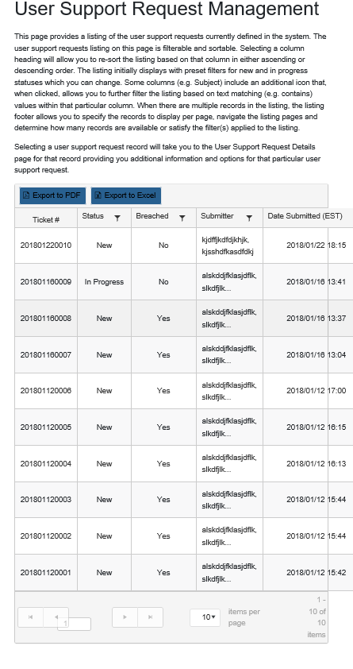  
  
User Support Request Details  
<http://spireportal-test.spire.com/UserSupportRequestManagement/Display/9>  
*Pass (Code)*  
*Fail (Bootstrap)*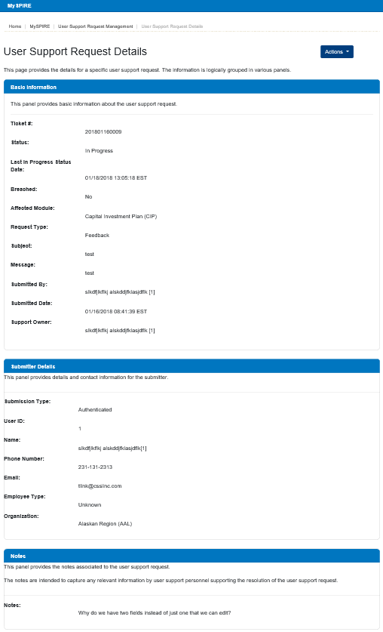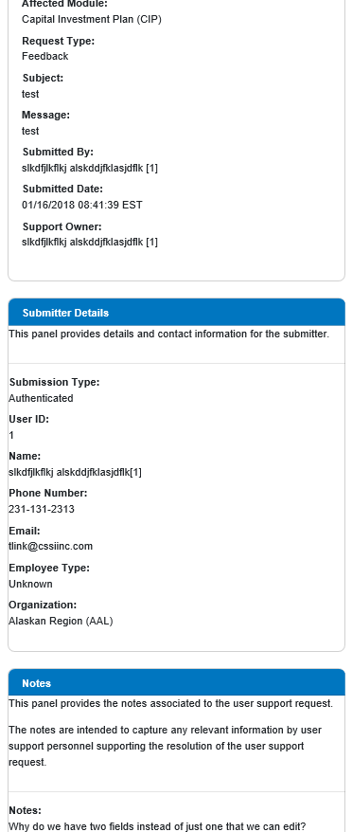***Actions Dropdown:***User Support Request – Change Affected Modulehttp://spireportal-test.spire.com/UserSupportRequestChangeModule/Edit/10  
*Pass (Code)  
Information in Fields: Pass (Success Message)  
Fail (Bootstrap)*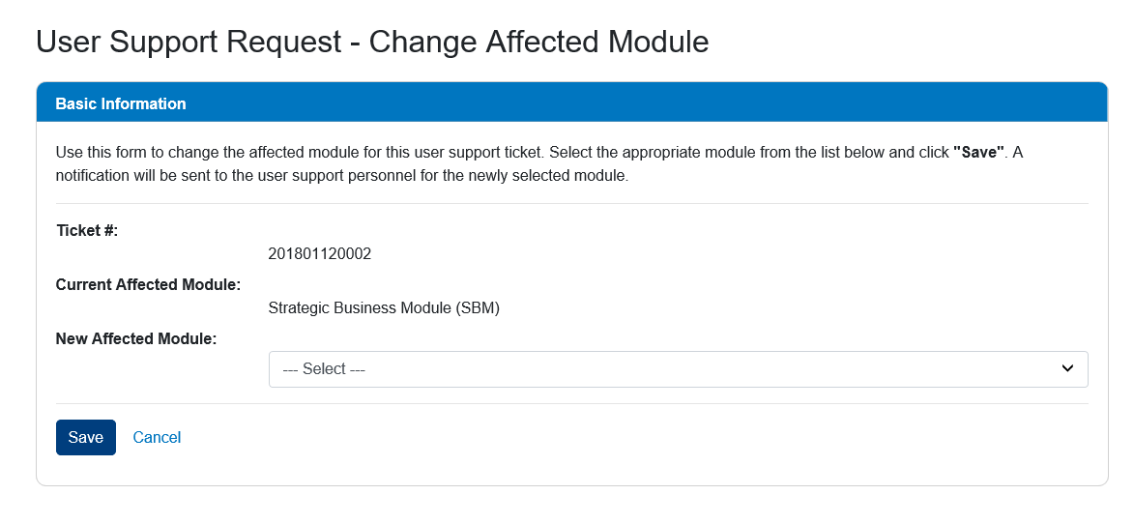  
User Support Request – Assign Ownerhttp://spireportal-test.spire.com/UserSupportRequestAssign/Edit/9  
*Pass (Code)  
Information in Fields: Pass (Success Message)*  
*Information not selected: Pass   
Fail (Bootstrap)*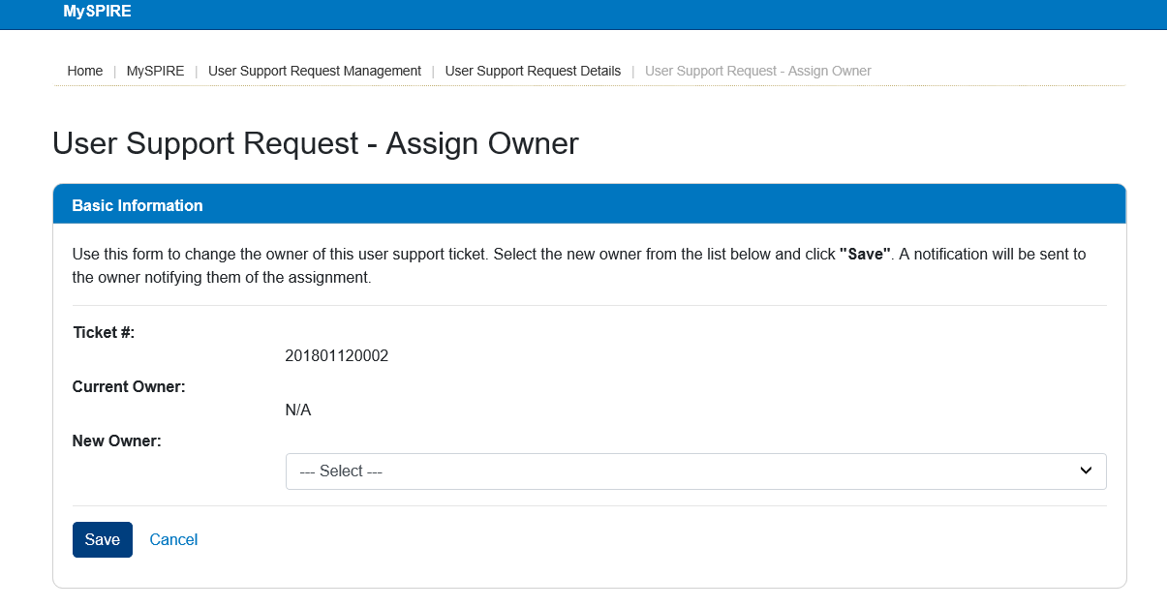User Support Request – Edit Noteshttp://spireportal-test.spire.com/UserSupportRequestNotes/Edit/9  
*Pass (Code)  
Information in Fields: Pass (Success Message)*  
*Fail (Bootstrap)*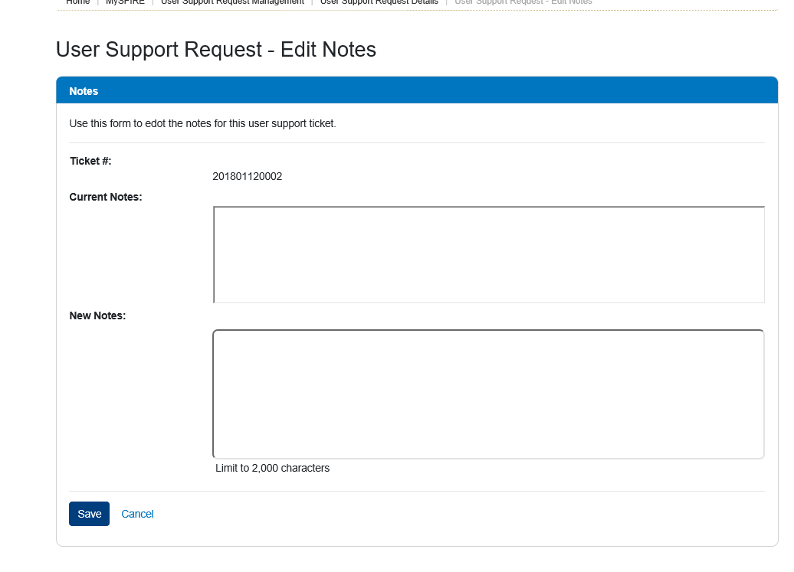

User Support Request – Close Tickethttp://spireportal-test.spire.com/UserSupportRequestResolution/Edit/9  
*Pass (Code)  
Information in Fields: Pass (Success Message)*  
*Fail (Bootstrap & Responsiveness)*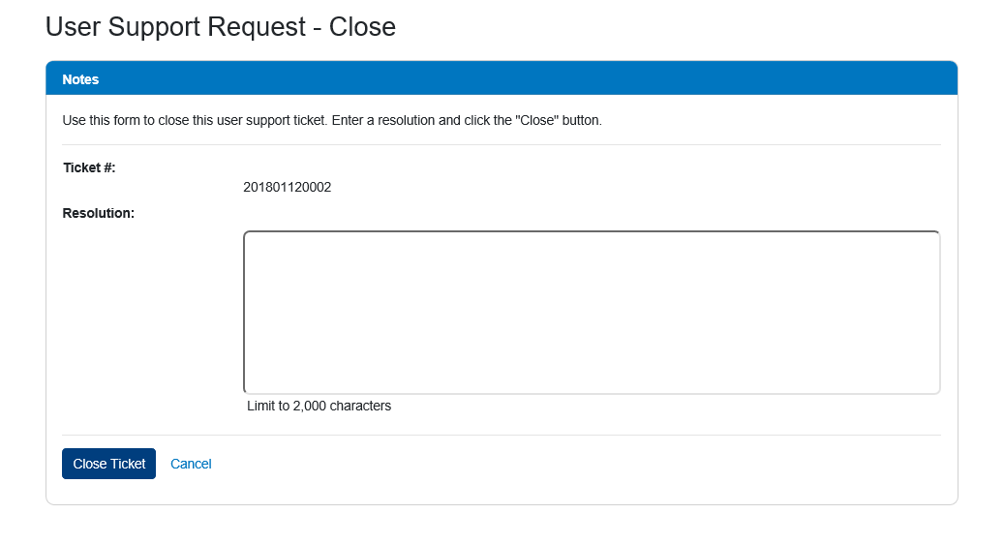

--------------------------------------------------------------------------- **Outreach Management**FAQ Management  
<http://spireportal-test.spire.com/FAQManagement>  
*Pass (Code)*  
*Fail (Bootstrap)*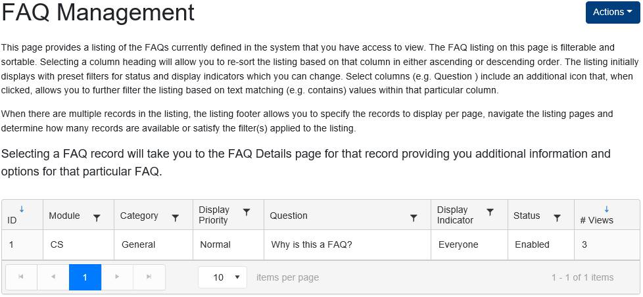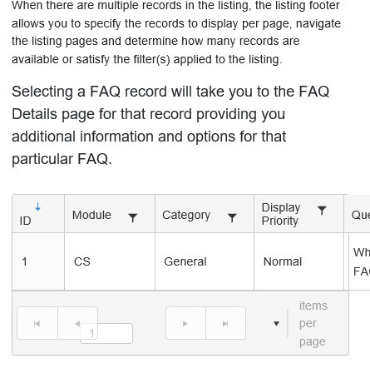 ***Actions Dropdown:***Create New FAQ<http://spireportal-test.spire.com/UserManagementEmail/Edit/13>  
*Information in Fields: Pass (Success Message)  
PDF & MP4 files under 50Mb: Pass (Code)*  
*Fail (Bootstrap)**Nothing in Fields: Fail (Hard Crash)  
  
If the user inserts nothing into the fields – Result:*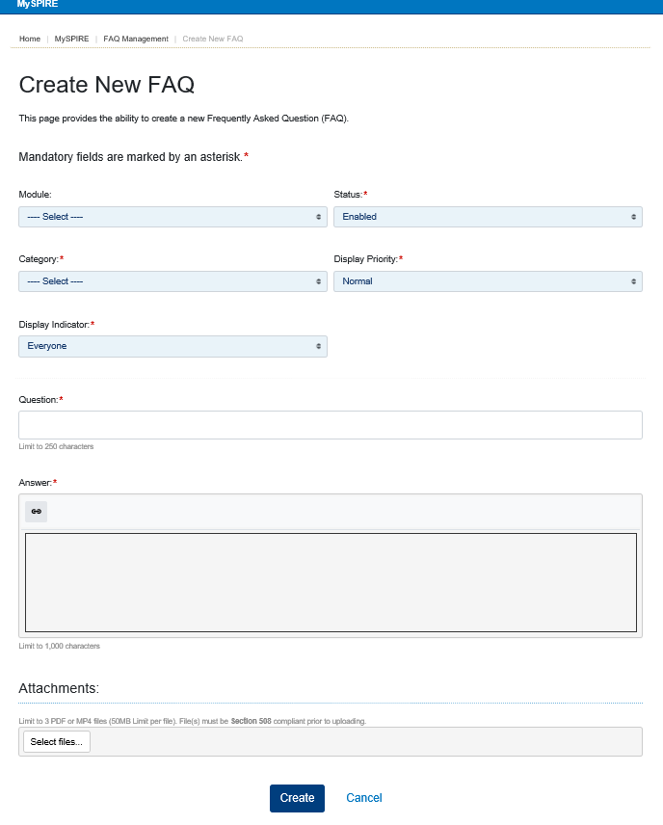 🡪    
*If the user selects a module then it displays errors but not all – Result:*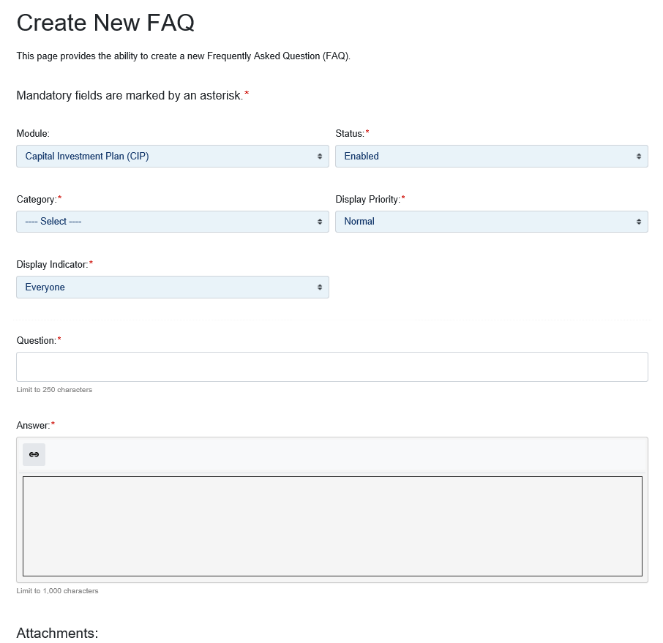 🡪 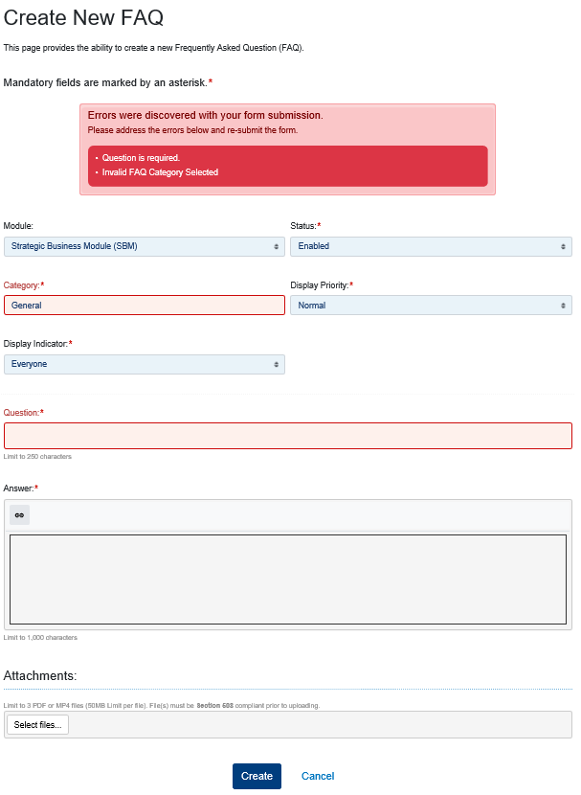 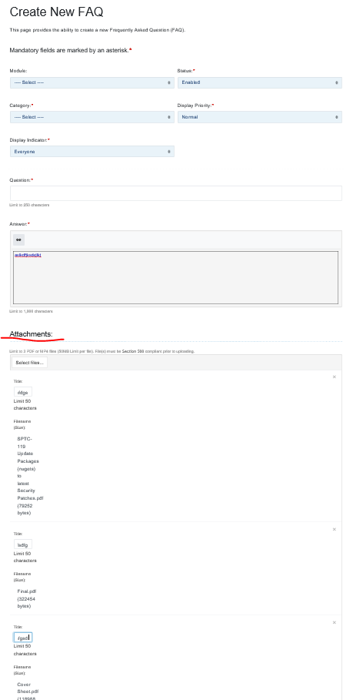  
  
FAQ Details  
http://spireportal-test.spire.com/FaqManagement/Display/2 *Pass (Bootstrap)  
Pass (Code)* ***Actions Dropdown:***Edit<http://spireportal-test.spire.com/FAQManagement/Edit/2>  
*Pass (Code)*  
*Fail (Bootstrap)**Nothing in Fields: Fail (Error Messages and highlights)*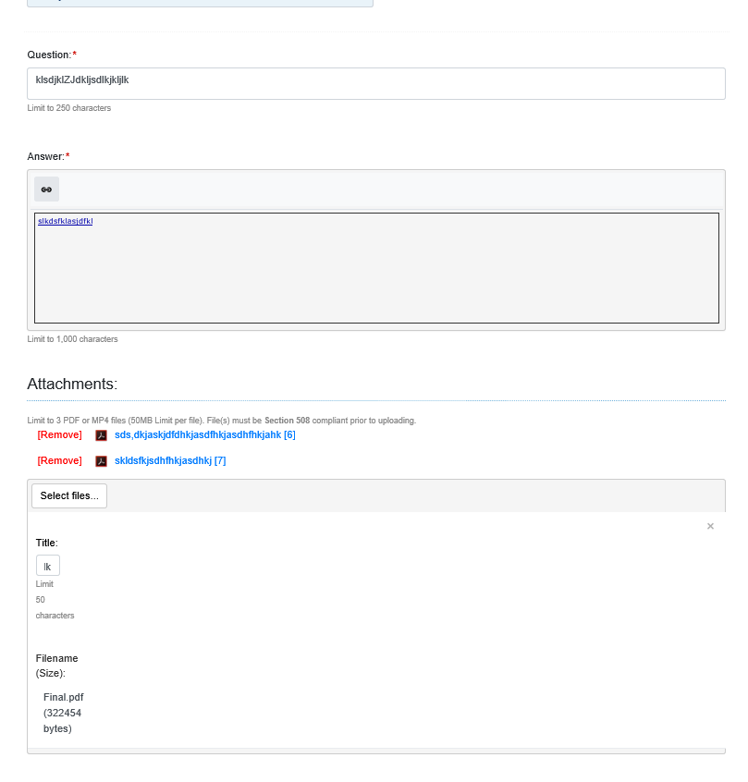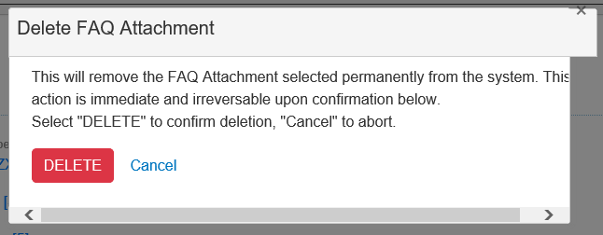Happens even if you select a module which is different from creating a FAQ and category does not get highlighted when editing

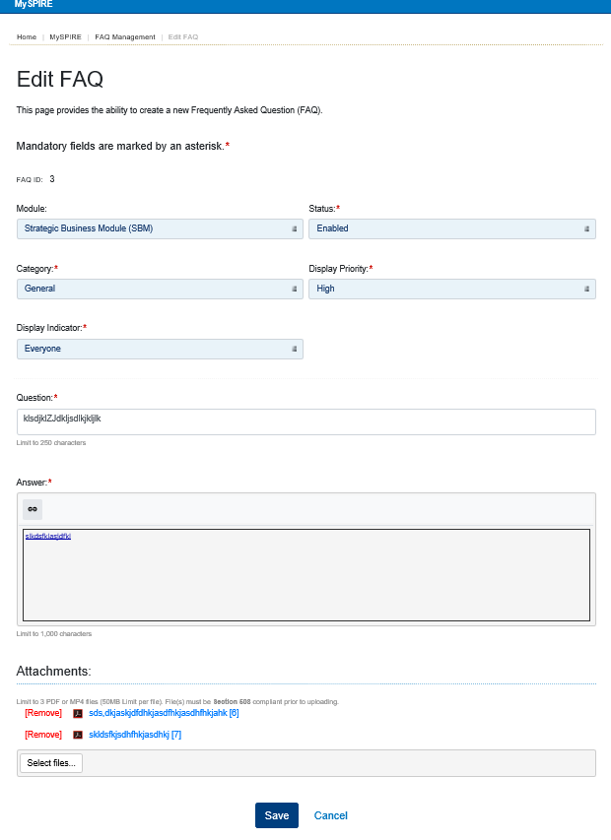 🡪 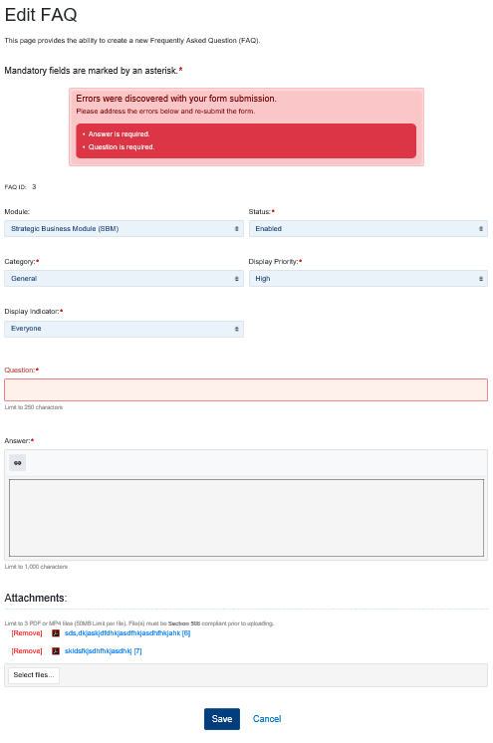

Delete  
*Pass (Success Message)*  
*Fail (Bootstrap)*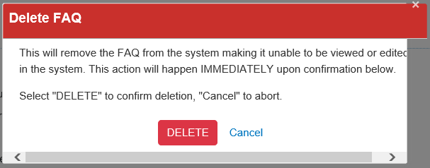  
Help Article Management  
<http://spireportal-test.spire.com/HelpArticleManagement>  
*Pass (Code)*  
*Fail (Bootstrap)*  
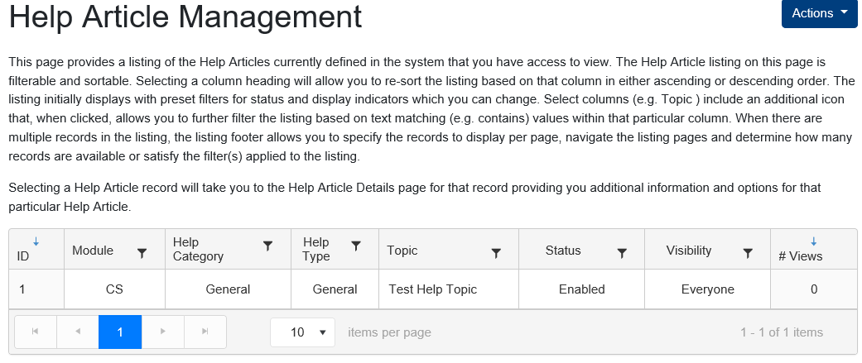 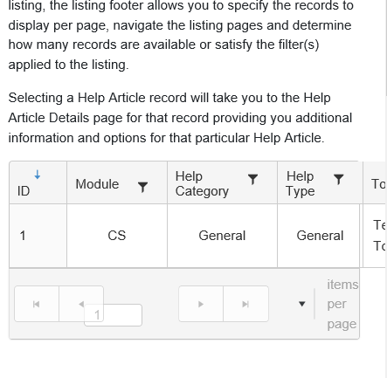  
 ***Actions Dropdown:***Create Help Article<http://spireportal-test.spire.com/HelpArticleManagement/Create>  
*Fail (Code)  
Information in Fields: Pass (Success Message)*  
*Fail (Bootstrap)**Nothing in Fields: Fail (Error Messages and highlights)*

Result When nothing is selected or entered:  
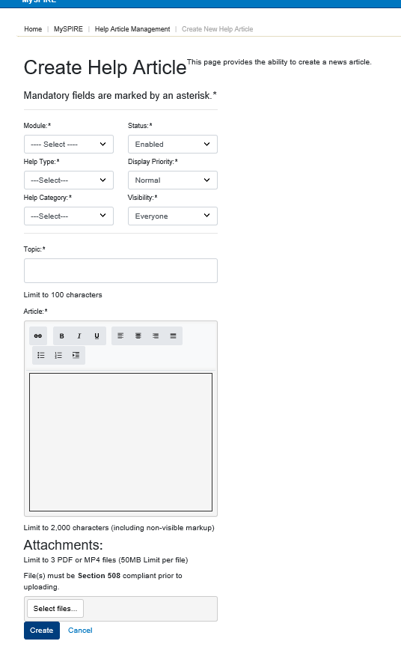 🡪Result When a module is selected:  
  
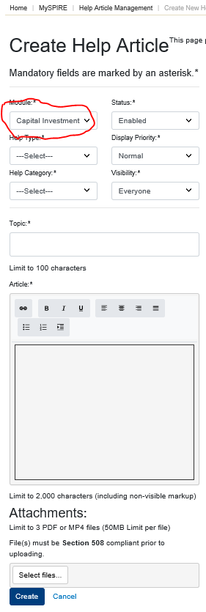 🡪 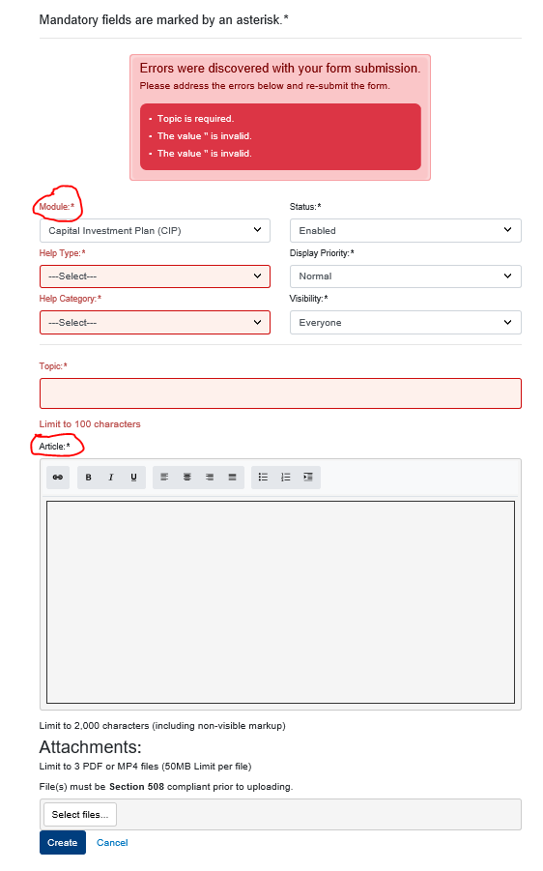

Help Article Details  
<http://spireportal-test.spire.com/HelpArticleManagement/Display/2>  
*Pass (Code)*  
*Fail (Bootstrap)*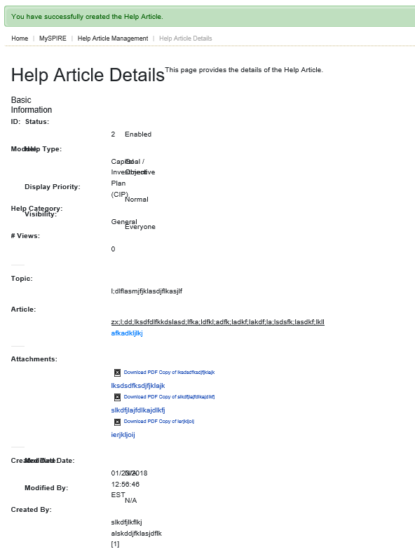  
  
Help Document Management  
<http://spireportal-test.spire.com/HelpDocumentManagement>  
*Pass (Code)*  
*Fail (Bootstrap)*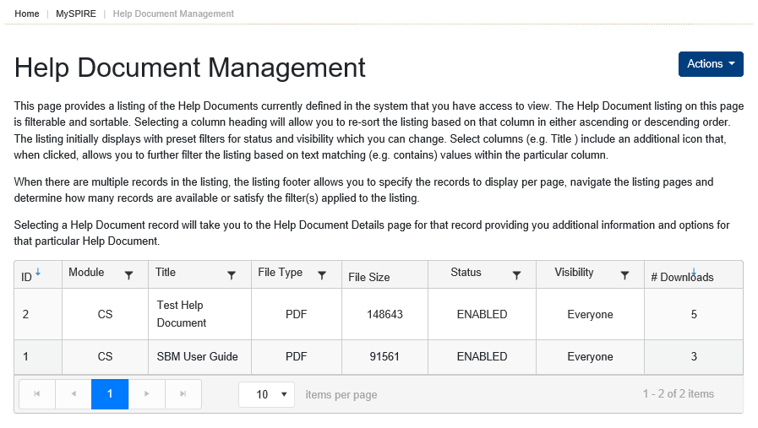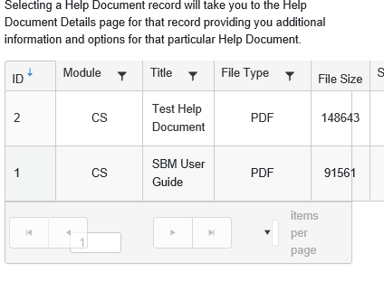

***Actions Dropdown:***Create Help Document<http://spireportal-test.spire.com/HelpArticleManagement/Create>  
*Nothing in Fields: Pass (Error Messages and highlights)*  
*Fail (Bootstrap)  
Information in Fields: Fail (Success Message)*  
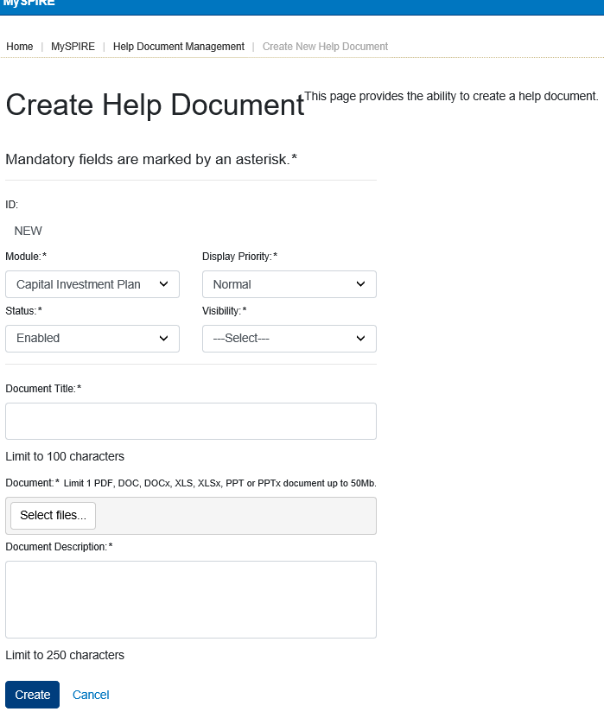 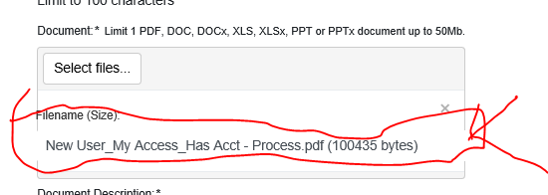   
  
Help Document Details  
<http://spireportal-test.spire.com/HelpDocumentManagement/Display/3>  
*Fail (Bootstrap)  
Fail (Code)*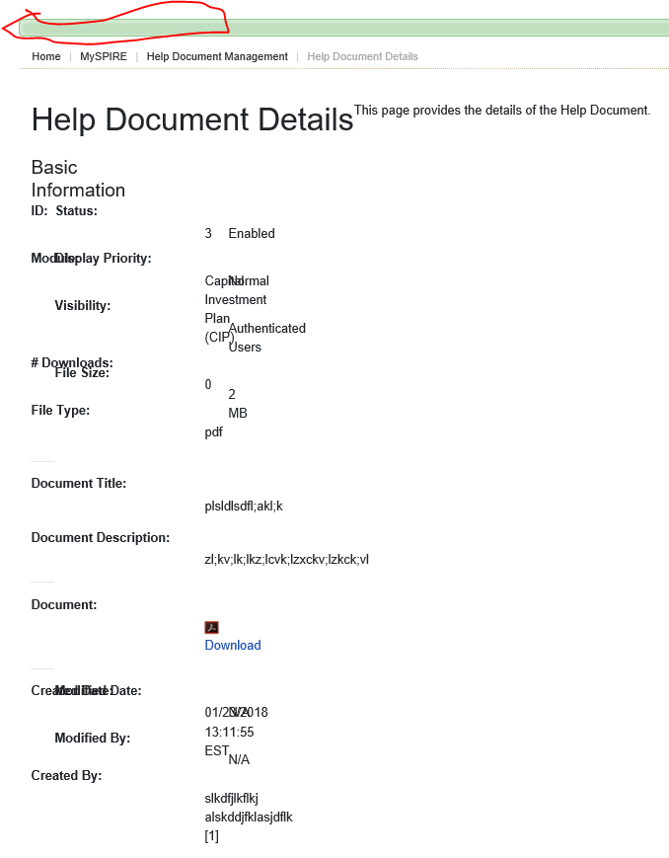  
  
News Management<http://spireportal-test.spire.com/NewsManagement/Index/2>  
*Pass (Code)*  
*Fail (Bootstrap)*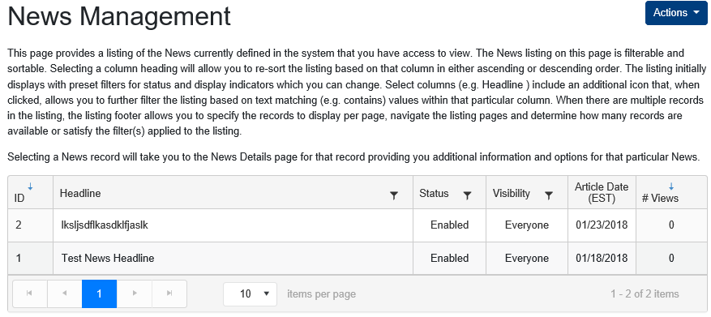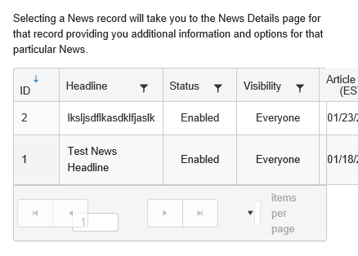 ***Actions Dropdown:***Create News Article<http://spireportal-test.spire.com/NewsManagement/Create>  
*Information in Fields: Pass (Success Message)* “Article” is missing  
*Fail (Bootstrap)**Nothing in Fields: Fail (Error Messages and highlights)*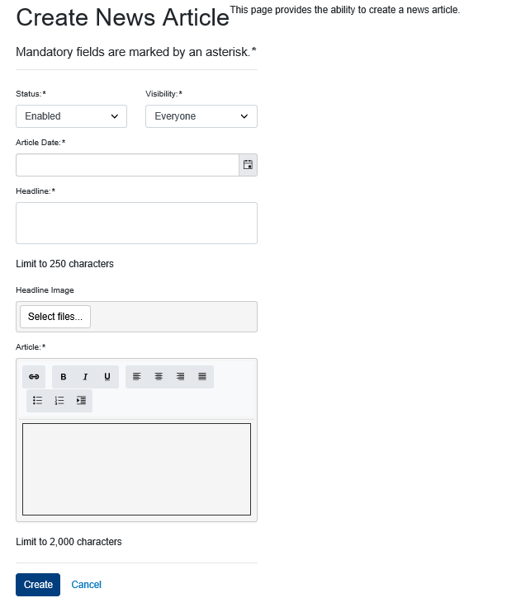 🡪 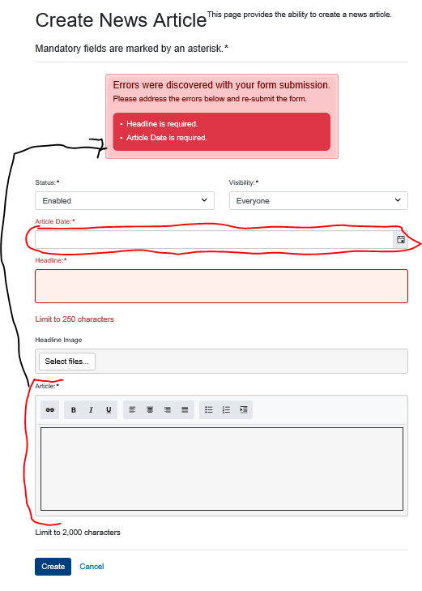  
  
News Article Details  
<http://spireportal-test.spire.com/NewsManagement/Display/3>  
*Pass (Code)**Fail (Bootstrap)*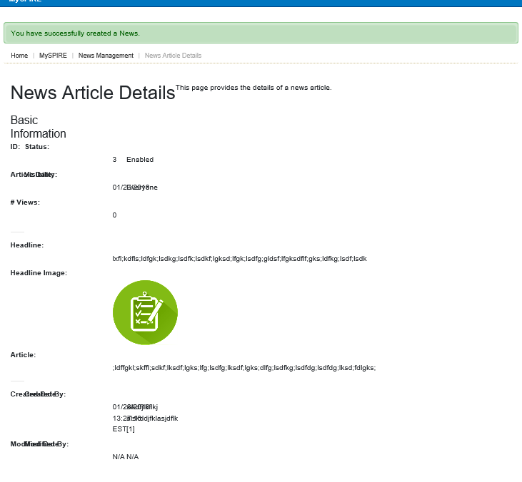 **Logs**View Request Log  
<http://spireportal-test.spire.com/RequestLog>  
*Pass (Code)**Fail (Bootstrap)*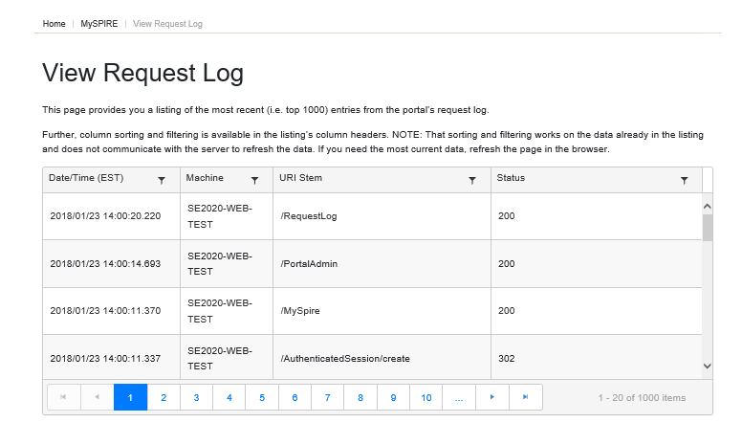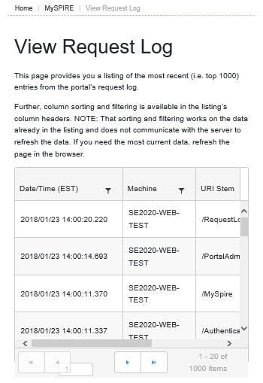 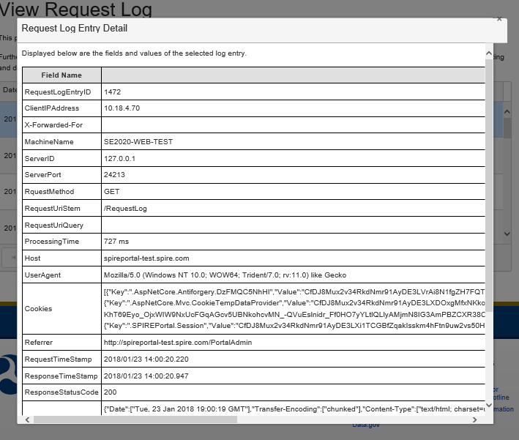  
View System Log  
<http://spireportal-test.spire.com/RequestLog>  
*Pass (Code)**Fail (Bootstrap & Responsiveness)*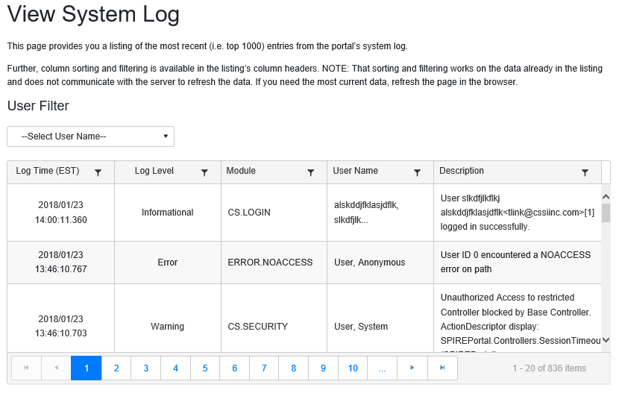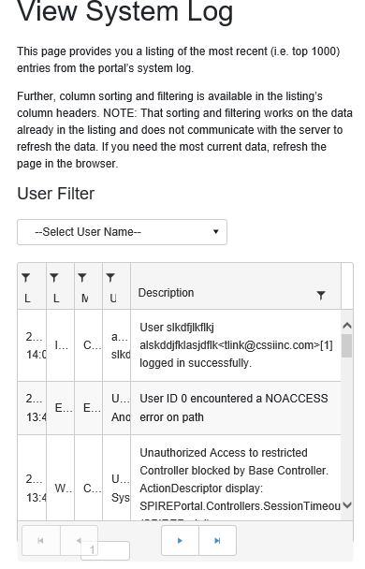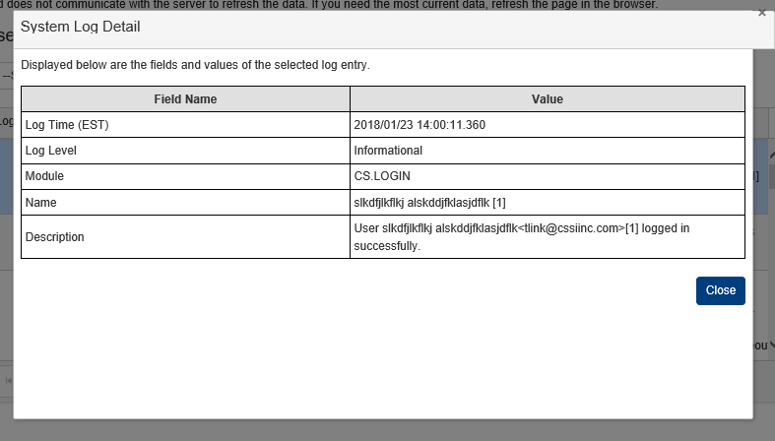 **Dashboards**Administrator Dashboard  
<http://spireportal-test.spire.com/AdminDashboard>  
*Pass (Code)**Fail (Bootstrap & Responsiveness)*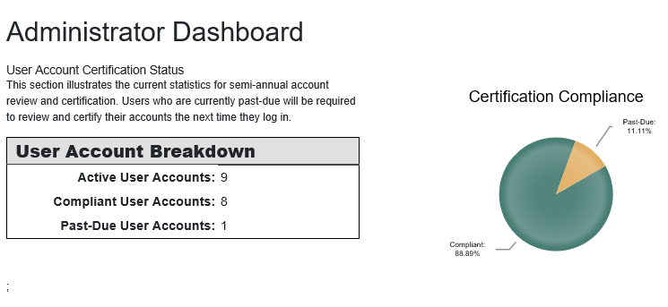  
  
General Site Metrics  
<http://spireportal-test.spire.com/PortalMetrics>  
*Pass (Code)**Fail (Bootstrap)*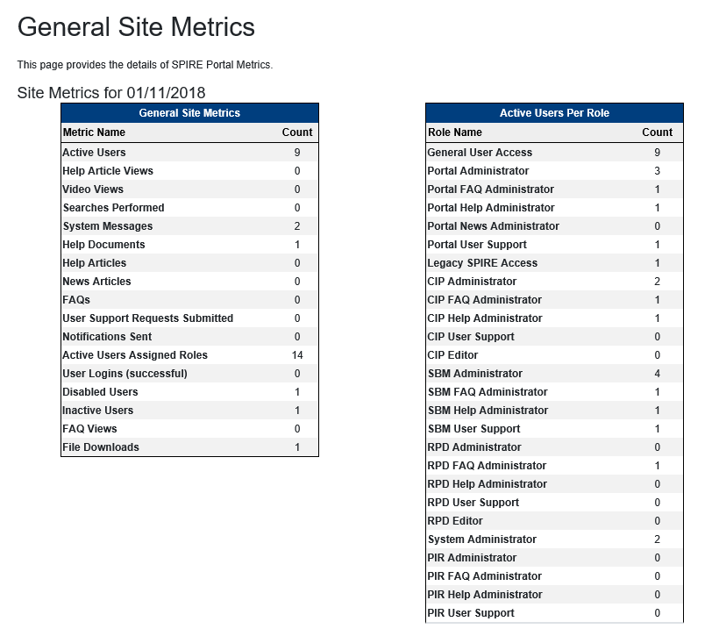Video Views Metric Trend  
<http://spireportal-test.spire.com/PortalMetrics/Display?Days=30&MetricID=3&MetricEntityID=0>  
*Pass (Code)**Fail (Bootstrap) Footer does not go all the way across.*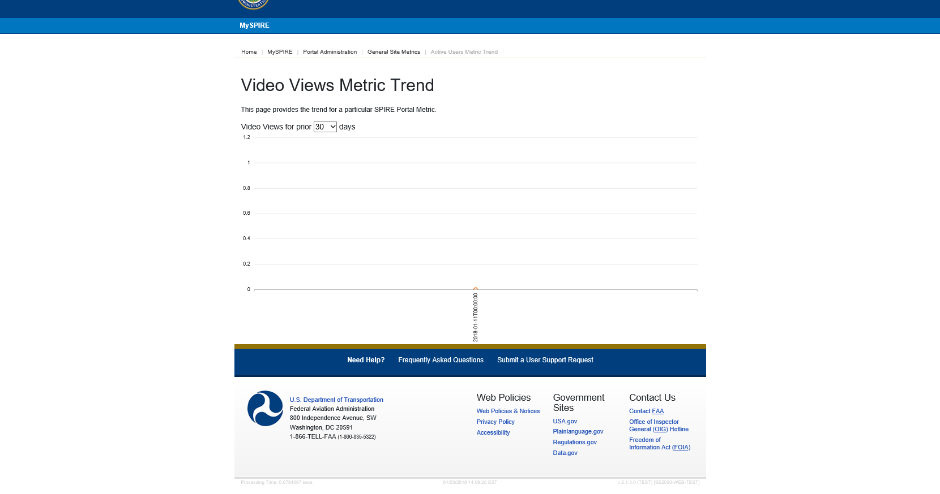  
Active Users In Role “Portal News Administrator” Metric Trend  
<http://spireportal-test.spire.com/PortalMetrics/Display?Days=30&MetricID=12&MetricEntityID=18>  
*Pass (Code)**Fail (Bootstrap & Responsiveness) Footer does not go all the way across.*  
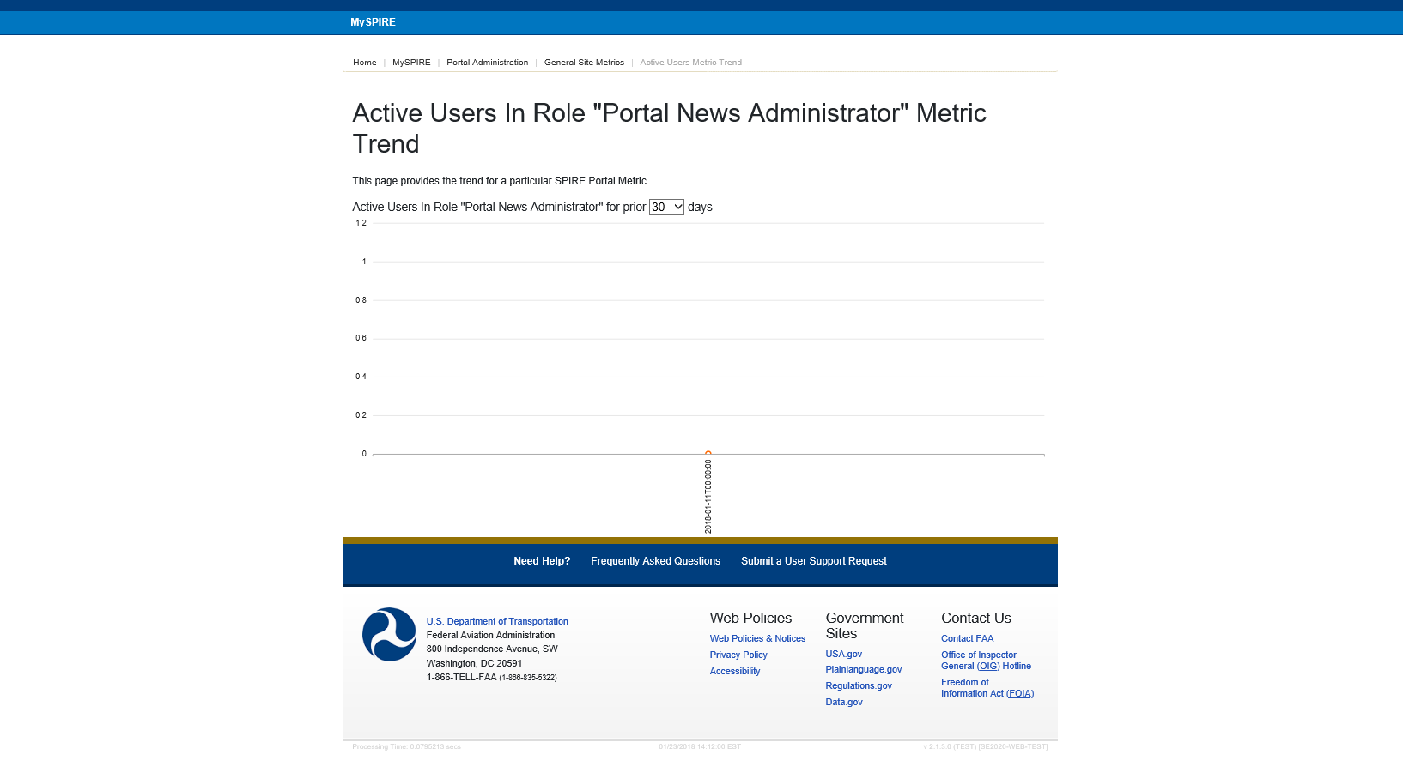

**System Administration**--------------------------------------------------------------------------------------------------------------------------------------Page Level Help Article Management  
http://spireportal-test.spire.com/PageHelpManagement  
*Pass (Code)**Fail (Bootstrap)*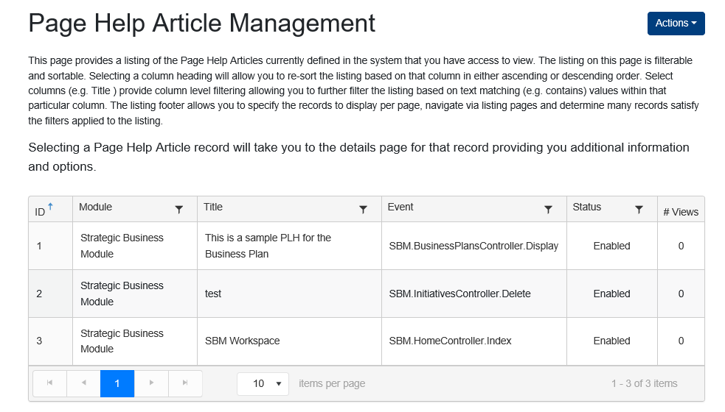 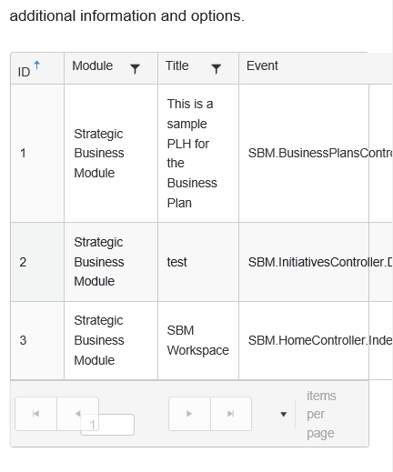  
  
***Actions Dropdown:***Create Page Help Articlehttp://spireportal-test.spire.com/PageHelpManagement/Create  
*Information in Fields: Pass (Success Message)*   
*Fail (Bootstrap)**Nothing in Fields: Fail (Error Messages and highlights)*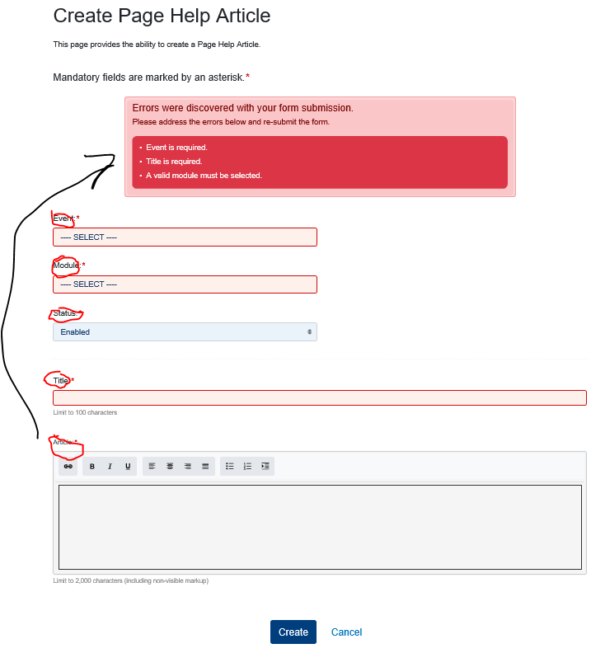Page Help Article Detailshttp://spireportal-test.spire.com/PageHelpManagement/Display/5  
*Pass (Code)*   
*Pass (Bootstrap)****Actions Dropdown:***Edit Page Help Article<http://spireportal-test.spire.com/PageHelpManagement/Edit/5>  
*Pass (Code)*  
*Information in Fields: Pass (Success Message)*   
*Fail (Bootstrap)**Nothing in Fields: Fail (Error Messages and highlights)*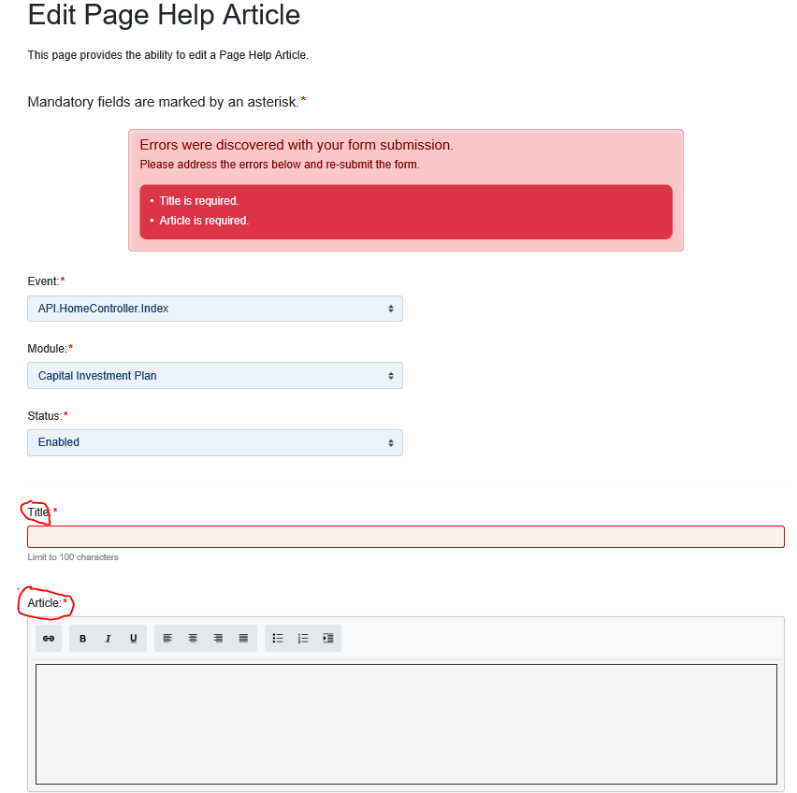  
Role Management  
http://spireportal-test.spire.com/RoleManagement  
*Pass (Code)**Fail (Bootstrap)*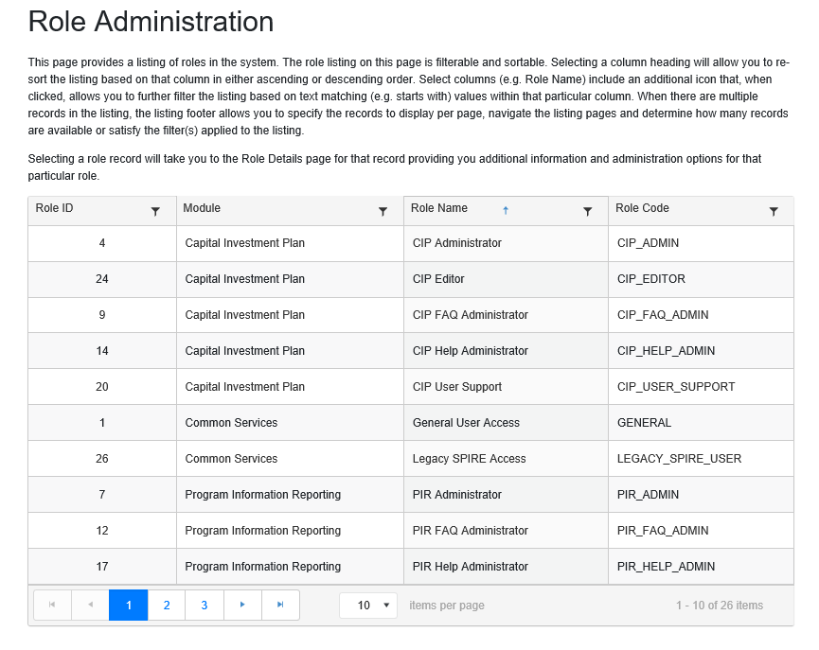Role Details  
http://spireportal-test.spire.com/RoleManagement/Display/20  
*Pass (Code)**Fail (Bootstrap)*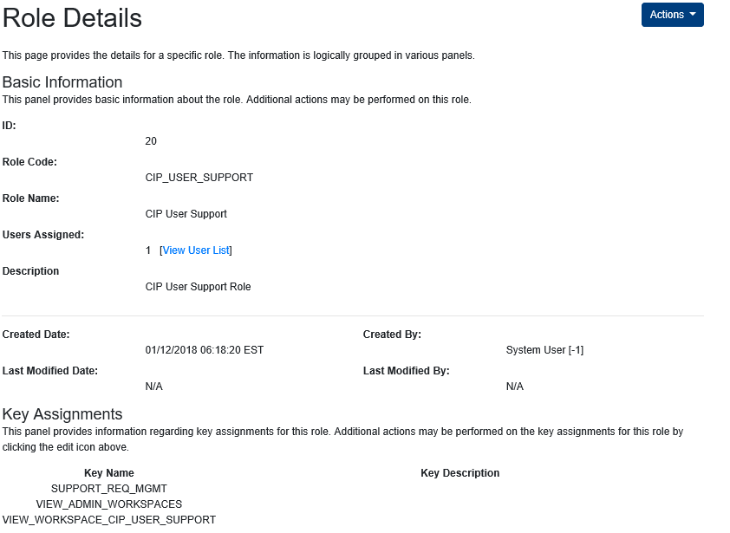***Actions Dropdown:***Edit Role Keyshttp://spireportal-test.spire.com/RoleKeyEdit/Index/20  
*Pass (Code)*  
*Remove: Pass (Success Message)*   
*Fail (Bootstrap)*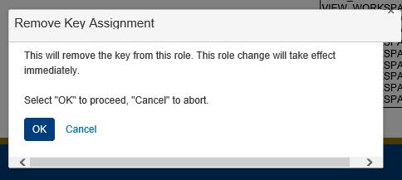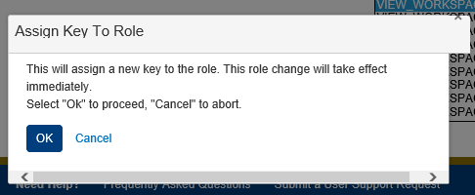Role Usershttp://spireportal-test.spire.com/RoleUsersManagement/Index/20  
*Pass (Code)*  
*Fail (Bootstrap)*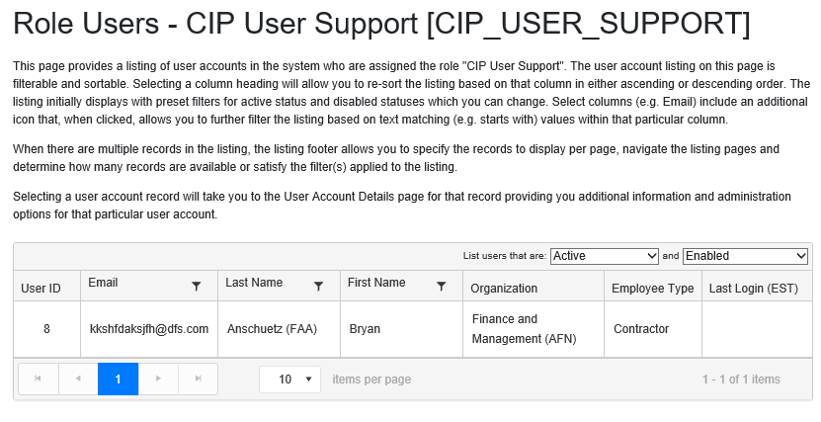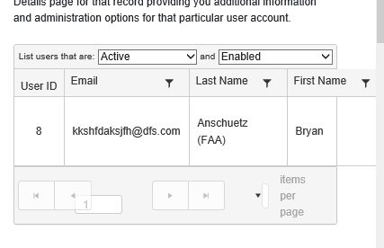**Strategic Business Module (SBM) Administration**--------------------------------------------------------------------------------------------------------------------------------------SBM Administrationhttp://spireportal-test.spire.com/SBM/Admin  
*Pass (Code)*  
*Pass (Bootstrap & Responsiveness)*  
General Management (Card)  
  
Fiscal Year Managementhttp://spireportal-test.spire.com/SBM/FiscalYearManagement  
*Pass (Code)*  
*Fail (Bootstrap)*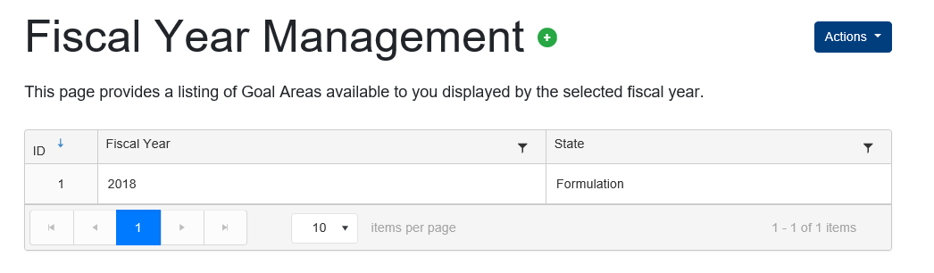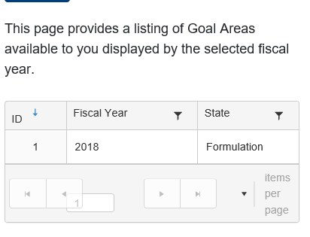***Actions Dropdown:***Create New Fiscal Year<http://spireportal-test.spire.com/SBM/FiscalYearManagement/Create>  
  
Fiscal Year Detailshttp://spireportal-test.spire.com/SBM/FiscalYearManagement/Display/1  
*Pass (Code)*  
*Pass (Bootstrap)*Goal Area Managementhttp://spireportal-test.spire.com/SBM/GoalAreaManagement  
*Pass (Code)*  
*Fail (Bootstrap)*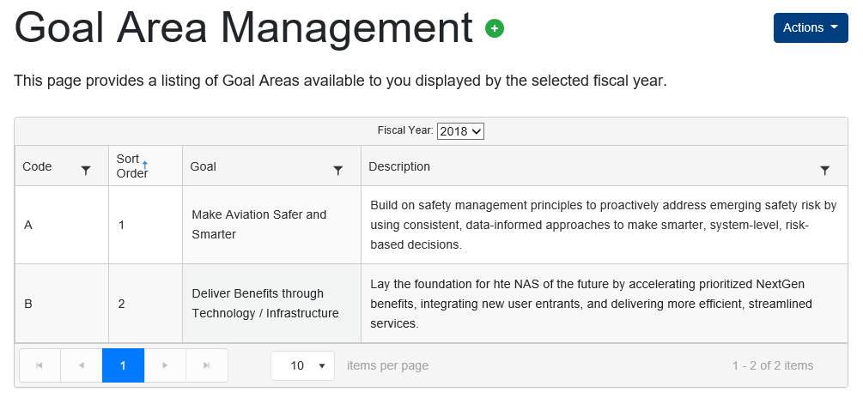***Actions Dropdown:***Create New Goal Area<http://spireportal-test.spire.com/SBM/GoalAreaManagement/Create/?FiscalYear=2018>  
*Pass (Code)*  
*Information in Fields: Pass (Success Message)*   
*Pass (Bootstrap)*  
  
Goal Area Detailshttp://spireportal-test.spire.com/SBM/FiscalYearManagement/Display/1  
*Pass (Code)*  
*Pass (Bootstrap)****Actions Dropdown:***Edit Goal Areahttp://spireportal-test.spire.com/SBM/GoalAreaManagement/Edit/3  
*Pass (Code)*  
*Information in Fields: Pass (Success Message)*   
*Pass (Bootstrap)*Delete Goal Area  
*Pass (Code)*  
*Fail (Bootstrap)*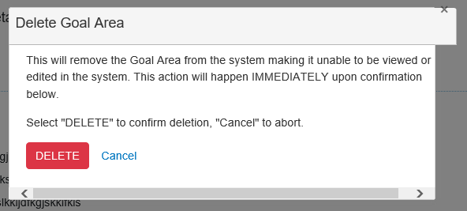**Strategic Business Module (SBM)**--------------------------------------------------------------------------------------------------------------------------------------  
SBMhttp://spireportal-test.spire.com/SBM  
*Pass (Code)*  
*Pass (Bootstrap)*  
  
Browse Business Planshttp://spireportal-test.spire.com/SBM/BrowseBusinessPlans/FY/2018  
*Pass (Code)*  
*Fail (Bootstrap)*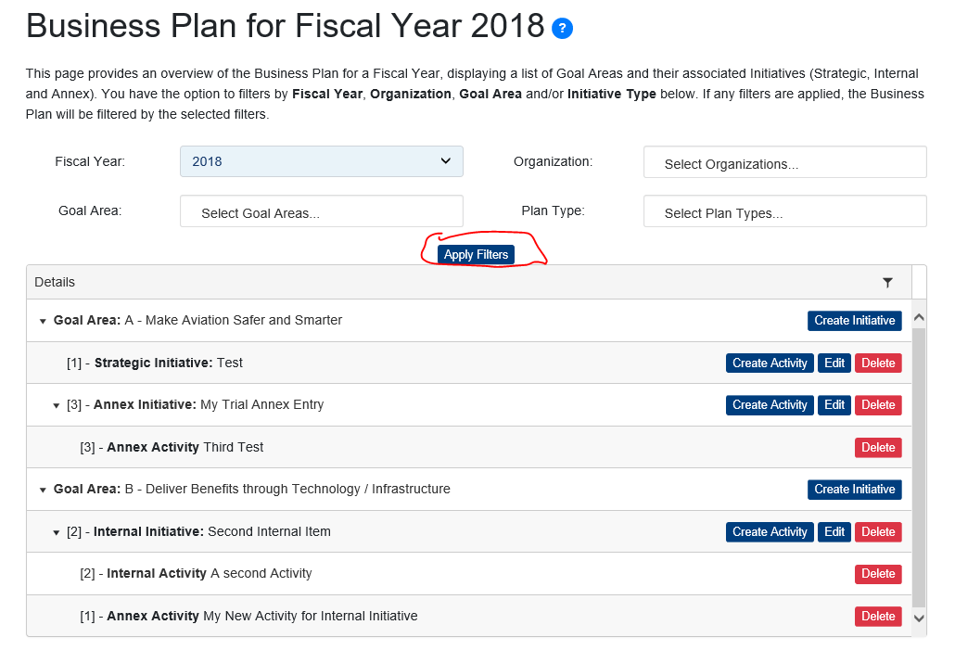 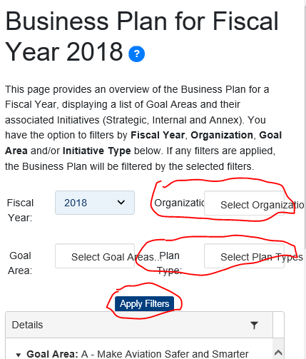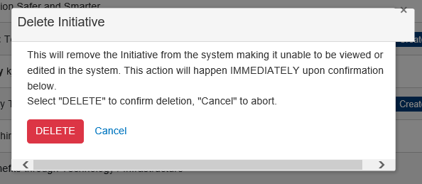***Actions:***Create Initiativehttp://spireportal-test.spire.com/SBM/Initiatives/Create/FY/2018/Goal/A  
*Information in Fields: Pass (Success Message)*   
*Fail (Bootstrap)**Nothing in Fields: Fail (Error Messages and highlights)*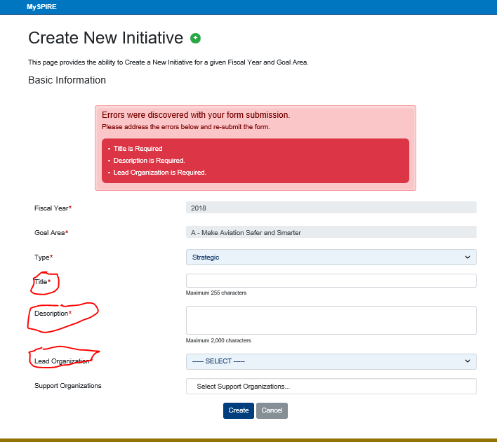Create Activityhttp://spireportal-test.spire.com/SBM/Activities/Create/1  
*Information in Fields: Pass (Success Message)*   
*Fail (Bootstrap)**Nothing in Fields: Fail (Error Messages and highlights)*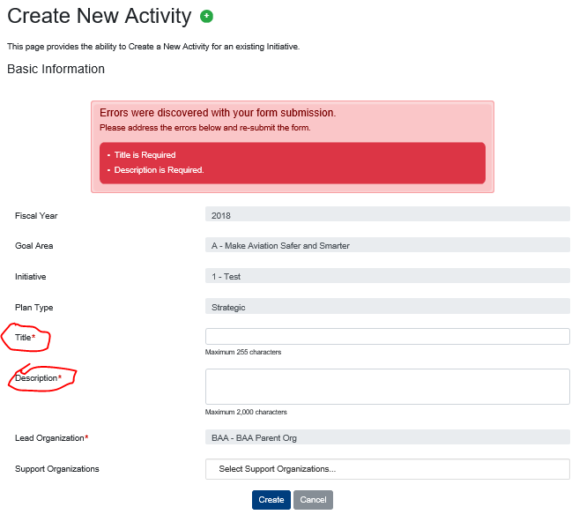

Edit Initiativehttp://spireportal-test.spire.com/SBM/Initiatives/Edit/1  
*Information in Fields: Pass (Success Message)*   
*Fail (Bootstrap)**Nothing in Fields: Fail (Error Messages and highlights)*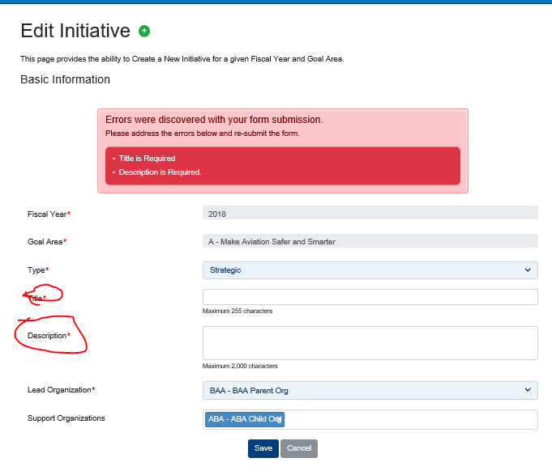

Delete Initiative  
*Information in Fields: Pass (Success Message & Warning Message)*   
*Fail (Bootstrap)*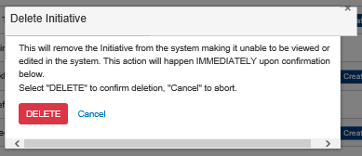  
Delete Activity  
*Information in Fields: Pass (Success Message)*   
*Fail (Bootstrap)*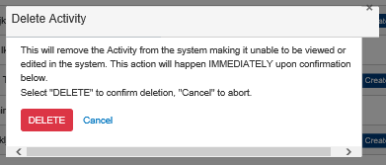  
  
Business Plan for Fiscal Year 2018http://spireportal-test.spire.com/SBM/BrowseBusinessPlans/FY/2018  
*Pass (Code)*  
*Fail (Bootstrap)*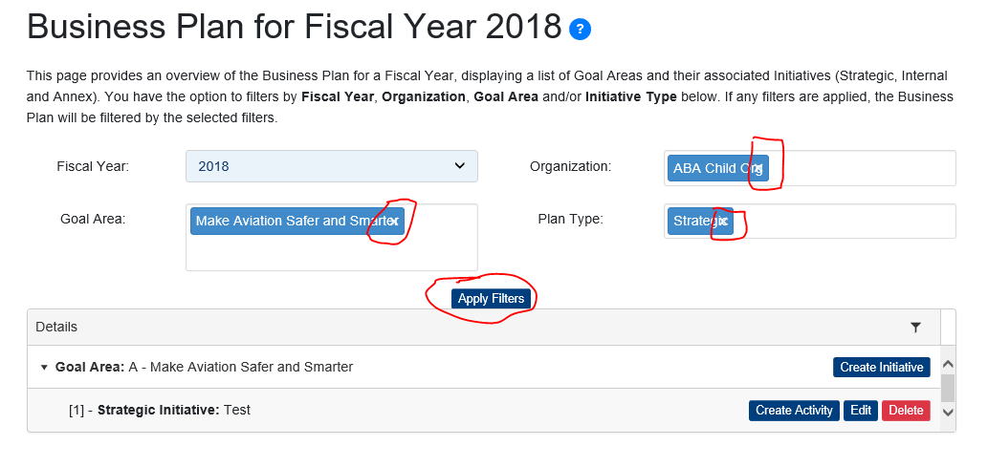Organization Managementhttp://spireportal-test.spire.com/SBM/OrganizationManagement  
*Pass (Code)*  
*Fail (Bootstrap)*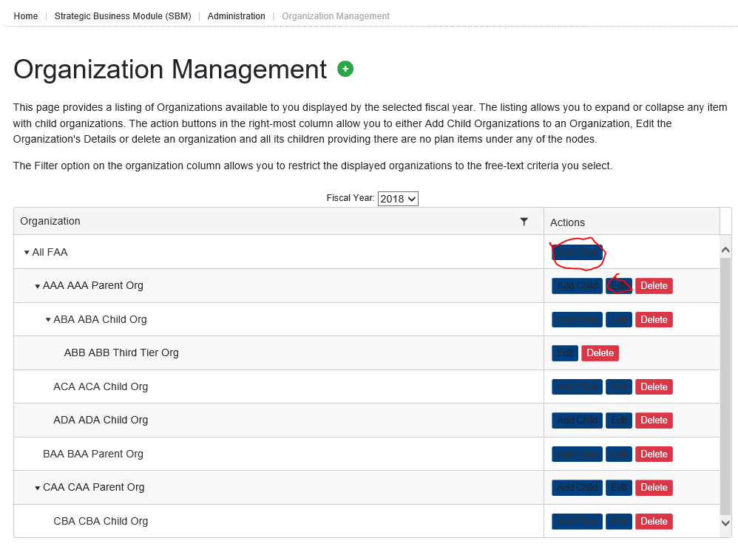***Actions:***Add Child<http://spireportal-test.spire.com/SBM/OrganizationManagement/Create/2>  
*Pass (Code)  
Information in Fields: Pass (Success Message)*  
*Pass (Bootstrap)*Edit Organizationhttp://spireportal-test.spire.com/SBM/OrganizationManagement/Edit/2  
*Pass (Code)  
Information in Fields: Pass (Success Message)*  
*Pass (Bootstrap)*Delete  
*Pass (Code)*  
*Fail (Bootstrap)*